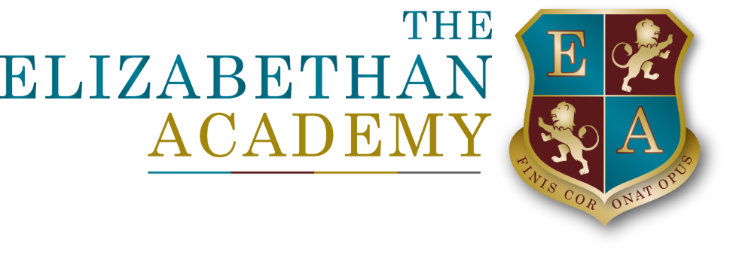

November 2021

Dear Student

Are you eligible for a school bursary award?

We have a funding allocation set aside to help 16-19 year olds remain in full-time education in our Sixth Form during 2022/23, who might otherwise struggle to do so for financial reasons. It is known as the ’16-19 Bursary Fund’.

The school’s Governing Body has devised a policy, which sets out the criteria to be applied for making awards from the Fund during the 2022/23 Academic Year. You can view our school‘s Bursary Award policy for 2021/ 22 on our website and hard copies of it are available from the Finance Office on request.

Please read the policy information carefully and consider whether this applies to you. If you are in doubt then please come and see either myself, or Mr D’Albuquerque in the Finance Department to discuss further. Help and support is available so please do not miss out on this opportunity.

If you do not meet any of the above criteria, but you have exceptional financial circumstances impacting on your ability to remain in full-time education, please forward written details to the school Sixth Form for consideration as to whether any financial support is available and can be provided.

All Bursary Award payments will be subject to your satisfactory attendance, behaviour and attainment. Your Bursary Award may be reduced if your attendance falls below 98% without an acceptable reason or if the school considers your behaviour/attainment to be unsatisfactory. Bursary Awards are weighted 50% on attendance and 50% on behaviour/attainment.

If you believe you qualify for the 16–19 Bursary Award then please complete the application form that can be found on the school website and return it to the Finance Office FAO Mr D’Albuquerque straight-away.

Yours sincerely

Mr L Dainty
Assistant Principal and Director of Sixth Form


