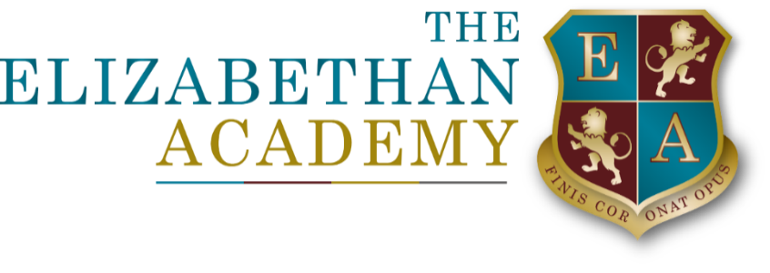

Parent and Carer Privacy Notice
Mrs L Barnes
17 April 2026

Document Control Table
Document title: |  |  |  | Parent and Carer Privacy Notice
Author (name & job title): |  |  |  | Mrs L Barnes
Version number: |  |  |  | 3
Date approved:
Approved by:
Date of review: |  |  |  | 17.4.27
Document History
Version | Date | Review | Author |  | Note of revisions
3 | 17.4.26 |  | L Barnes |  | Updated

Table of Contents
Parent and Carer Privacy Notice 4
1. About this privacy notice 4
2. Who we are (Data Controller) 4
3. What personal data we collect about parents and carers 4
Personal and contact details 4
Administrative and financial information 5
Safeguarding and legal information 5
Technical information 5
4. How and why we use parent and carer information 5
5. Special category data 6
6. How we collect parent and carer information 6
7. Call recording and communications monitoring 6
Call recording 6
Communications systems 7
8. How we store and retain parent and carer information 7
9. Who we share parent and carer information with 7
10. Department for Education (DfE) 7
11. International data transfers 7
12. Your data protection rights 8
13. Complaints 8
14. Contact details 8

Parent and Carer Privacy Notice

1. About this privacy notice
The Elizabethan Academy is required by law to collect and process personal information about parents and carers in order to fulfil its statutory duties as an academy trust and to support pupils effectively.
This privacy notice explains how we collect, use, store and share personal information relating to parents and carers in accordance with the UK General Data Protection Regulation (UK GDPR) and the Data Protection Act 2018.
This notice should be read alongside our separate Pupil Privacy Notice.

2. Who we are (Data Controller)
The Data Controller is:
The Elizabethan Academy
Hallcroft Road
Retford
Nottinghamshire
DN22 7PY
Company Number: 7964360
We have appointed a Data Protection Officer (DPO) to oversee compliance with data protection law.

Data Protection Officer

Mrs L Barnes
Email: head@elizabethan.notts.sch.uk
(Please clearly mark correspondence for the attention of the Data Protection Officer)

3. What personal data we collect about parents and carers
We may collect and process the following information about parents and carers:

Personal and contact details
- Name
- Relationship to the pupil
- Address
- Email address
- Telephone numbers
- Emergency contact details
- Parental responsibility information

Administrative and financial information
- Records of communication with the Academy
- Correspondence and meeting notes
- Financial records relating to payments made to the Academy, outstanding balances and recovery action
- Bank or payment details (where applicable)

Safeguarding and legal information
- Information relating to safeguarding concerns
- Information shared with or received from external agencies
- Court orders or legal documentation where relevant

Technical information
- Records of your use of Academy communication systems
- Call recordings (inbound and outbound)
We may also process limited information about you in relation to your child, for example where necessary for safeguarding, educational support or statutory reporting.

4. How and why we use parent and carer information
We use parent and carer personal data for the following purposes:
Purpose | Lawful basis
To fulfil our statutory duties as a school and academy trust | Legal obligation / Public task
To communicate with parents and carers regarding pupil education, wellbeing and school activities | Public task / Legitimate interests
To manage safeguarding and welfare concerns | Legal obligation / Public task
To administer school services and payments | Contract
To maintain security of staff, pupils and visitors | Legal obligation / Public task
To improve our services and communications | Legitimate interests
Where required, to obtain and manage consent | Consent
Where we rely on consent, you may withdraw it at any time.

5. Special category data
In some circumstances, we may process special category data relating to parents or carers, for example:
- Information disclosed during safeguarding processes
- Information relating to court proceedings
- Health information where necessary in relation to a pupil
We only process special category data where permitted by law, including under:
- Article 9 UK GDPR
- Schedule 1, Data Protection Act 2018 (including safeguarding and statutory purposes)

6. How we collect parent and carer information
Most information is provided directly by parents and carers, for example:
- Admission forms
- Contact updates
- Correspondence and meetings
- Payment systems
We may also receive information from third parties, including:
- Local authorities
- Courts and legal professionals
- Health and social care professionals
- Law enforcement agencies
Some information is required by law. Where information is optional, this will be made clear.

7. Call recording and communications monitoring

Call recording
Telephone calls to and from the Academy may be recorded for:
- Safeguarding
- Training and quality assurance
- Security and dispute resolution
Recordings are accessed only by authorised staff and retained in line with our Retention Policy.

Communications systems
We maintain logs and records of communications through Academy systems in order to ensure appropriate use and maintain security.

8. How we store and retain parent and carer information
We retain parent and carer personal data only for as long as necessary and in accordance with our Retention Policy.
- Information linked to a pupil’s record is retained in line with statutory education guidance
- Other records are securely deleted or destroyed once no longer required
Retention schedules are available on request.

9. Who we share parent and carer information with
We may share parent and carer information with:
- Local authorities
- The Department for Education (DfE)
- Courts and tribunals
- Law enforcement agencies
- Safeguarding partners
- Professional advisers (e.g. auditors, insurers, legal advisers)
- IT and administrative service providers used by the Academy.
We only share information where lawful and necessary.

10. Department for Education (DfE)
In some cases, information provided by parents/carers may be included as part of statutory returns made to the DfE, where required by law.
The DfE processes this data under its own privacy notices:
- https://www.gov.uk/government/publications/privacy-information-early-years-foundation-stage-to-key-stage-3
- https://www.gov.uk/government/publications/privacy-information-key-stage-4-and-5-and-adult-education

11. International data transfers
We do not routinely transfer parent or carer personal data outside the UK. Where cloud-based systems are used, appropriate safeguards are in place to ensure UK GDPR compliance.

12. Your data protection rights
Parents and carers have the following rights under data protection law:
- The right to be informed
- The right of access (Subject Access Request)
- The right to rectification
- The right to erasure (in limited circumstances)
- The right to restrict processing
- The right to object (in limited circumstances)
- The right to withdraw consent (where applicable)
- Rights relating to automated decision-making
Some rights do not apply where processing is necessary for legal or public task purposes.

13. Complaints
If you have concerns about how your personal data is handled, please contact us first.
You may also complain to the regulator:
Information Commissioner’s Office (ICO)
Wycliffe House
Water Lane
Wilmslow
Cheshire SK9 5AF
Website: https://www.ico.org.uk
Telephone: 0303 123 1113

14. Contact details
For questions about this privacy notice or to exercise your data protection rights, please contact:
Mrs L Barnes, Data Protection Officer
Email: head@elizabethan.notts.sch.uk

