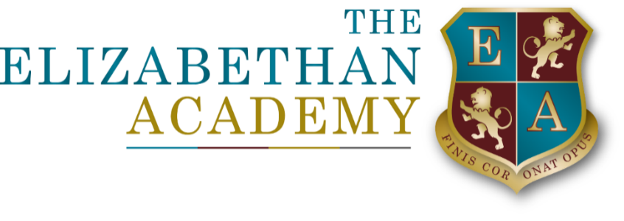

Pupil Privacy Notice
Mrs L Barnes
17 April 2026

Document Control Table
Document title: |  |  |  | Pupil Privacy Notice
Author (name & job title): |  |  |  | Mrs L Barnes
Version number: |  |  |  | 3
Date approved:
Approved by:
Date of review: |  |  |  | April 2027
Document History
Version | Date | Review | Author |  | Note of revisions
3 | 17.4.26 | 17.4.27 | L Barnes |  | Updated

Table of Contents
Pupil Privacy Notice 4
1. Who we are 4
2. What information do we collect about you? 4
3. Why do we need this information? 4
4. Where do we get your information from? 5
5. What do we use your information for? 5
6. CCTV and monitoring 5
7. Biometric information 5
8. Where do we keep your information? 5
9. How long do we keep your information? 6
10. Who do we share your information with? 6
11. Your rights 6
12. Contact 6

Pupil Privacy Notice

1. Who we are
We are The Elizabethan Academy.
We are your school and we are responsible for looking after the information we collect about you.
This notice explains how we use your information and how we keep it safe.
If you would like help understanding this notice, you can ask a parent/carer, a teacher or another trusted adult.

2. What information do we collect about you?
While you are a pupil at the Academy, we collect and use some information about you. This includes:
- Your name, date of birth and contact details
- Information about your family or people who care for you
- Attendance information
- Information about how you are doing in lessons, tests and exams
- Behaviour, rewards and achievement information
- Information about your health, wellbeing or special educational needs
- Dietary requirements
- Safeguarding information
- Information about support you receive in school
- Photographs and videos
- CCTV images
- Biometric information (for example, cashless catering systems)
We only collect information that we need to teach you, support you and keep you safe.

3. Why do we need this information?
We collect this information because:
- We have a legal duty to do so
- We need it to help you learn and achieve your best
- We need it to make sure you get the right support
- We need it to help keep you and others safe
- We are required to share certain information with the government or local authority

4. Where do we get your information from?
Most information is given to us by your parents or carers when you start school.
We also collect information from:
- You
- Your previous school
- Teachers and other school staff
- The local authority or other organisations that help support you

5. What do we use your information for?
We use your information to:
- Teach you and help you make progress
- Support your health and wellbeing
- Make sure school is a safe place for everyone
- Monitor attendance and behaviour
- Provide extra support where needed
- Follow the law and government guidance

6. CCTV and monitoring
We use CCTV around the school site to help keep everyone safe.
CCTV images are only seen by staff who need to see them and are kept securely for a limited time.
We also monitor the use of school computer systems to help keep pupils safe online.

7. Biometric information
We may use biometric systems (such as fingerprints or facial recognition) for cashless catering.
- These systems are optional
- Your parent or carer must give permission
- You will not be treated differently if you do not use them
- A different way to pay for food will always be available

8. Where do we keep your information?
Your information is stored securely in our computer systems and paper files.
Only staff who need your information to teach you, support you or keep you safe are allowed to see it.

9. How long do we keep your information?
We keep your information while you are a pupil at the Academy.
If you move to another school, we will pass your records to your new school.
After you leave, we keep your information for a period of time because we are required to by law. After that, it is securely destroyed.

10. Who do we share your information with?
Sometimes we have to share information about you with other organisations, such as:
- Your new school if you move
- The local authority
- The Department for Education
- Exam boards
- Health and safeguarding services
- The police or courts, if required by law
We only share information when we are allowed to and when it is necessary.

11. Your rights
You have rights over your information. This means you can:
- Ask what information we hold about you
- Ask us to correct information if it is wrong
- Ask for information to be restricted in some cases
- Ask questions about how your information is used
Your parent or carer can help you exercise these rights.

12. Contact
If you have questions about this privacy notice or how your information is used, you can speak to a trusted adult or contact our Data Protection Officer, Mrs L Barnes.
Email: head@elizabethan.notts.sch.uk

