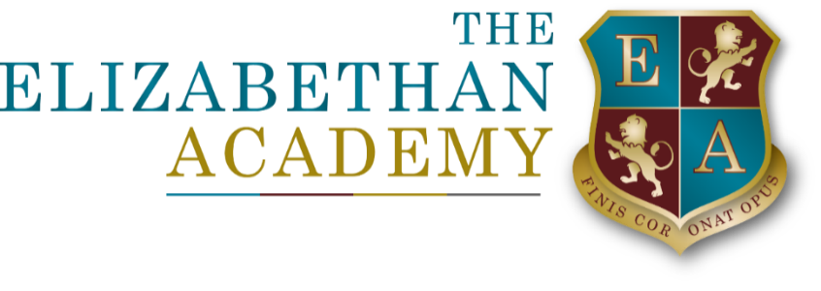

GDPR Request Templates and Procedures
L Barnes DPO
13 November 2025

Document Control Table
Document title: |  |  |  | GDPR Request Templates and Procedures
Author (name & job title): |  |  |  | L Barnes DPO
Version number: |  |  |  | 1
Date approved: |  |  |  | Feb 2025
Approved by: |  |  |  | COO
Date of review: |  |  |  | Feb 2028
Document History
Version | Date | Review | Author |  | Note of revisions
1 | Feb 2025 | New | L Barnes |  | New

Contents
Subject Access Request 4
Freedom of Information Requests 6

Subject Access Request

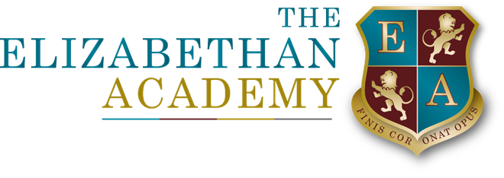

GDPR Request Templates and Procedures

To be completed by Data Subjects wanting access to their personal data held by the organisation, or to be completed on behalf of the Data Subject by their authorised representatives

Subject access request form

You can use this form to request access to the personal information held by the trust/academy about you or as a parent/carer about your child(ren). If you are requesting information about your child(ren), we will generally seek consent directly from a student/pupil where it is deemed that they would understand the information being requested, why it is being requested and what the requester will be using the information for. Whilst UK GDPR does not set an age related limit, the Academy deems this to be from year 9 (12/13 year olds) however we recognise that in certain circumstances this may not be appropriate and therefore we may seek consent from an individual with parental responsibility. Please see the authority at the end of this form.

Under the UK General Data Protection Regulation (UK GDPR) data subjects have a right to be told whether the academy – or someone else on the academy’s behalf – is processing your personal data and, if so, to be given a description of:

• the personal data held;
• the purposes for which that personal data is being processed;
• those to whom that personal data is being or may be disclosed.

The regulations Right of access | ICO state that organisations have one calendar month to respond to a subject access request (SAR) and we will always endeavour to comply with this. Where that is not possible, for whatever reason, we will keep you informed. During school closures (e.g. holidays), we may require an extension as staff may not be on site to complete the request within the timescale but we will deal with it as soon as the academy re-opens and will keep you informed of when you will receive the information.

Section One – your details

Surname:

First name(s):

Address:

Phone:

Email:

If the information relates to a student at the Academy please provide the name and age of the student/s about whose personal data you are requiring:

Do you have parental responsibility for the student who is the ‘data subject’. If the answer is no please provide justification for your request.

Please ensure you enclose proof of your identity – such as a photocopy of your passport, driving licence, birth certificate or utility bill. Please provide a description of the data you are requesting in the box below. You may continue overleaf if needed. You should describe the information you need as clearly as possible: it is not sufficient to ask for ‘everything about me’. If your request is too broad or unclear, we may need to ask you to be more specific.

Section two – declaration

I am the enquirer named in section one of this form and request that The Elizabethan Academy provide me with a copy of the personal data held for the Data Subject. I enclose proof of my identity.

Signed

Date

Subject reference request – consent by student

Name

DOB

Address

Please sign as appropriate:

I consent to the release of my personal data/information as requested to: ……………………………………………………….. (insert name)

Relationship to you…………………………………..

The academy will advise ………………………………….. (insert name) of the date information is available to collect from The Academy.

Please provide contact details (mobile number/email or postal address)

Signed (student)

Date

OR

I request that the personal data/information as requested by …………………………

(insert name) be released only to me. The Academy will advise you of the date

information is available to collect from the Academy.

…………………………………….(student name) will be required to sign to

acknowledge receipt of the information.

Signed (student)

Date

Please send the completed form to the Data Protection Officer

Mrs L Barnes dpo@elizabethan.notts.sch.uk

The Elizabethan Academy
Hallcroft Road
Retford
Notts DN22 7PY

Freedom of Information Requests
Contents
1 Publication scheme statement
Vision, mission and values
Purpose and intent
Roles and Responsibilities
Benefits
2Publication Scheme
Who can ask for information
How to ask for information
How information published under this scheme will be made available (refer to Appendix A)
Charges which may be made for information published under this scheme (refer to Appendix B)
Written requests
Review of the policy
Appendix A: Information to be published

Publication scheme statement
Vision, mission and values
We are committed to being open and transparent as an organisation. We aim to publish as much information as possible on our trust and academy websites.
Purpose and intent
We recognise our duty to:
• provide advice and assistance to anyone requesting information. We will help enquirers to put more complex requests into writing so that they can be handled
• inform enquirers whether or not we hold the information they are requesting (the duty to confirm or deny), and provide access to the information we hold in accordance with the procedures laid down
• ensure that all classified personal data, including electronic and paper copies, are held securely and transferred securely and only to authorised individuals or agencies. We accept that failure to comply may result in an investigation and/or fines from the Information Commissioner (ICO). This publication scheme commits us to make information available to the public as part of its normal business activities.
Roles and responsibilities
Our Trustees have overall responsibility for the effective operation of this scheme and for ensuring compliance with the relevant statutory framework.
Benefits
1.1 The Freedom of Information Act 2000 (FOIA) provides public access to information held by public authorities. This publication scheme commits us to make information available to the public and our stakeholders as part of our activities.
1.2 It does this in two ways:
• we, as a public authority is obliged to publish certain information about our activities
• members of the public are entitled to request information from us (public authorities). Any requests must be made in writing.
1.3 The scheme gives greater openness and transparency with our stakeholders and the general public.
Publication Scheme
Who can ask for information
2.1 The Freedom of Information Act deals with non-personal data held by the academy.
a. Any person has a legal right to ask for access to information held. They are entitled to be told whether the academy holds the information, and to receive a copy, subject to certain exemptions.
b. The information which the academy routinely makes available to the public is included in this scheme
c. Requests for other information should be dealt with in accordance with the guidance below. While the act assumes openness, it recognises that certain information is classified. There are exemptions to protect this information. The publication scheme commits us to make information available to the public as part of its normal business activities. Definition document: Schools in England sets out the information we should provide.

2.6 The scheme commits us:
a. To proactively publish or otherwise make available as a matter of routine, information, including environmental information, which is held by the trust and falls within the classifications below.
b. To specify the information held by the trust and falls within the classifications below.
c. To proactively publish or otherwise make available as a matter of routine, information in line with the statements contained within this scheme.
d. To produce and publish the methods by which the specific information is made routinely available so that it can be easily identified and accessed by members of the public.
e. To review and update on a regular basis the information the trust makes available under this scheme.
f. To produce a schedule of any fees charged for access to information which is made proactively available.
g. To make this publication scheme available to the public.
How to ask for information
We aim to publish as much information as possible on our trust and academy websites but if there is any other information that you require please email dpo@elizabethan.notts.sch.uk or write to:
Data Protection Officer,
The Elizabethan Academy,
Hallcroft Road,
Retford,
Notts. DN22 7PY
2.1 Please include your name, address and telephone number and your preferred method of response with your request. In order for us to consider your request it would be helpful if you could state why you are requesting the information.
2.2 All FOIA requests are managed initially via Head Office and therefore if your request relates to a specific academy, please send your request to the Data Protection Officer as above. Our academies will forward FOIA requests they receive to Head Office.
2.3 Your request will be acknowledged upon receipt and you will be advised when you may expect the information from us. Please see our charging policy below for information requested. We will write to you if a charge is likely to be payable to ascertain if you would like to continue with your request. All requests will be responded to within the 20 day (school day) or 60 working days (whichever is sooner) statutory time limit.
2.4 There may be times when requested information cannot be supplied. We will write to you if this applies to your request. You have the right to appeal the decision in writing in the first instance and your request will be reconsidered under our Complaints Policy process. Once your request has been through the above process you may also contact the Information Commissioner’s Office if you think our decision is unreasonable www.ico.org.uk
or write to:
Information Commissioner’s
Office Wycliffe House
Water Lane
Wilmslow
Cheshire
SK9 5AF
How information published under this scheme will be made available
3.1 We will indicate clearly to the public what information is covered by this scheme and how it can be obtained.
3.2 Where it is within the capability of the academy, information will be provided on our website. Where it is impracticable to make information available on a website or when an individual does not wish to access the information via the website, we will indicate how information can be obtained by other means and provide it by those means.
3.3 In exceptional circumstances some information may be available only by viewing in person. Where this manner is specified, contact details will be provided. An appointment to view the information will be arranged within a reasonable timescale.
3.4 Information will be provided in the language in which it is held or in such other language that is legally required. Where there is a legal requirement to translate any information, we will do so.
3.5 Obligations under disability and discrimination legislation and any other legislation to provide information in other forms and formats will be adhered to when providing information in accordance with this scheme.
Charges which may be made for information published under this scheme (refer to Appendix A)
4.1 The purpose of this scheme is to make the maximum amount of information readily available at minimum inconvenience and cost to the public.
Charges made by us for routinely published material will be justified and transparent and kept to a minimum.
4.2 Material which is published and accessed on a website will be provided free of charge. Charges may be made for information subject to a charging regime specified by Parliament.
4.3 Charges may be made for actual disbursements incurred such as:
• photocopying
• postage and packaging
• the costs directly incurred as a result of viewing information.
4.4 Charges may also be made for information provided under this scheme where they are legally authorised and justified and are in accordance with a published schedule or schedules of fees which is readily available to the public.
4.5 If a charge is to be made, confirmation of the payment due will be given before the information is provided. Payment will be requested prior to provision of the information. Written requests All requests must be received in writing. Information held by us as a public authority that is not published under this scheme can also be requested, when its provision will be considered in accordance with the provisions of the Freedom of Information Act.

Appendix A: Schedule of charges Charges
These are the charges made by us for copies of documents and other information under the Freedom of Information Act:
• Website – access to the website is free of charge unless otherwise specified
• Email and attachments – free of charge unless otherwise specified
• Website printouts – printouts from the trust, school website or external websites are not provided
• Copies by post of all information:
Photocopies A4 pages at 20p per page (single sided) black and white, 25p per page colour (single sided) A3 pages at 30p per page (single sided) black and white, 35p per page colour (single sided) A2 pages at £1.30 per page (single sided) black and white, £1.55 per page colour (single sided) Accumulated charges under £5 will be free
• Photocopies: information accessed in the Head Office or academy office can be viewed free of charge, photocopies can be made according to the scale charges above. Postage for standard letters (first and second class) charges will not be made. For larger collections of material, postage will be charged for any item or items in excess of a cost of £2. Administration fees: charges can, in accordance with the relevant legislation, legally be made for administration where a request will take a significant amount of staff time. Such charges are calculated at £25 per hour with a maximum limit of £450. We are within our statutory rights to refuse to comply with a request where the cost to provide it will exceed 18 hours. Guidance will be given to the requester on how they could refine their request to make it less onerous. Alternatively, we may comply with the request for an extra charge which will be advised to you prior to starting the work. The fee will be payable in full before supplying the information.
• These charges will be reviewed when the policy is reviewed.

