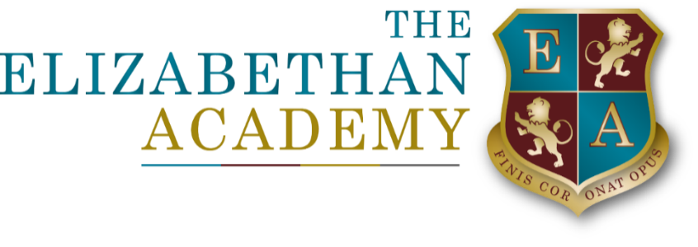

Relationships, Sex and Health Educations Policy
Mandy Stocks
24 September 2025

Document Control Table
Document title: |  |  |  | Relationships, Sex and Health Educations Policy
Author (name & job title): |  |  |  | Mandy Stocks
Version number: |  |  |  | 1.3
Date approved: |  |  |  | June 2025
Approved by:
Date of review: |  |  |  | June 2027
Document History
Version | Date | Review | Author |  | Note of revisions
1.3 | June 25 | June 27 | Mandy Stocks |  | Updates

Table of Contents
1. Aims 4
2. STATUTORY REQUIREMENTS 4
3. POLICY DEVELOPMENT 4
4. DEFINITION 5
5. CURRICULUM 5
6. DELIVERY OF RSHE 6
6.1 Relationship of Sex Education 6
6.2 Health Education 7
7. ROLES AND RESPONSIBILITIES 7
7.1 Governing Body 7
7.2 Senior LEadership Team 7
7.3 Staff 8
7.4 Pupils 8
8. PARENTS’ RIGHT TO WITHDRAW 9
9. SAFEGUARDING, REPORTS AND ABUSE AND CONFIDENTIALITY 9
Appendix 1: RSHE Statutory Guidance…………………………………………………………………………………………………….10
Appendix 2: Parent form for withdrawal from sex education 13

Aims
The aims of Relationships, Sex and Health Education (RSHE) at The Elizabethan Academy are to:
· Provide a framework in which sensitive and supportive discussions can take place
· Ensure pupils understand the issues surrounding relationships, including sexual relationships, and health, and have the necessary knowledge to make informed decisions
· Prepare pupils for puberty, and give them an understanding of sexual development and the importance of health and hygiene
· Help pupils develop feelings of self-respect, confidence and empathy
· Create a positive culture around issues of sexuality and relationships
· Teach pupils the correct vocabulary to describe themselves, their bodies and the different relationships that can exist
· Promote understanding and tolerance of others’ beliefs
· Promote good mental and physical well-being, including healthy eating and fitness
· Raise awareness and understanding of the risks posed by the internet and how to keep safe
· Underline the core values of the school in teaching respect, responsibility and resilience as part of the development of the whole child

STATUTORY REQUIREMENTS
As a secondary academy, we must provide RSHE to all pupils as per section 34 of the Children and Social Work Act 2017 and the new statutory guidance: Relationships Education, Relationships and Sex Education (RSE) and Health Education 2020.
In teaching RSHE, we are required by our funding agreements to have regard to guidance issued by the secretary of state as outlined in section 403 of the Education Act 1996

POLICY DEVELOPMENT

This policy has been developed in consultation with staff and parents.
Parents were provided with a copy of the government’s leaflet: Understanding Relationships, Sex and Health Education at your child’s secondary school: a guide for parents. This explained the key purposes of the new RSHE curriculum which aims to ensure that all children:
· grow up healthy, happy and safe
· are able to manage the challenges and opportunities of modern Britain
· are equipped with the knowledge to make informed decisions about their wellbeing, health and relationships
· are prepared for a successful adult life
Parents were informed that the school would have flexibility to deliver the content in a way that they felt was age and developmentally appropriate as well as sensitive to the needs
and backgrounds of the students. They were also informed of their right to withdraw their child (Section 8 and Appendix 3).
Information was provided on the 13 areas of the new RSHE curriculum and parents were invited to comment on any aspects of content or delivery. It was explained that parents were free to express their opinions, and that this would help the school decide how and when to cover the content of the statutory guidance. It might also help them decide whether to teach additional non-statutory content.
Responses were received from a small number of parents, some of whom work professionally with young people in relationships, sex and health education, and their advice was invaluable in writing this policy and also in developing the new teaching resources.
One parent gave the following advice about delivering RSHE: “No one is going to get it 100 per cent right for all young people. We can just have the right intentions and be open minded I think. The teens teach me as much as I do them when we do session work.”

DEFINITION
RSHE is about the emotional, social and cultural development of pupils, and involves learning about relationships, sexual health, sexuality, healthy lifestyles, diversity and personal identity.
RSHE involves a combination of sharing information and exploring issues and values.
RSHE is not about the promotion of sexual activity.

CURRICULUM

RSHE forms part of the wider PSHCE (Personal, Social, Health and Careers Education) that is delivered twice weekly by Form Tutors to all students in Years 7 to 13 at the Elizabethan Academy. It also overlaps with the SMSC (Social, Moral, Spiritual and Cultural) education that schools are required to provide.
We have developed the curriculum in consultation with parents, pupils and staff, taking into account the age, needs and feelings of pupils. If pupils ask questions outside the scope of this policy, teachers will respond in an appropriate manner so they are fully informed and don’t seek answers online. Pupils are also encouraged to discuss the topics covered with their parents and raise any further questions they might have.

DELIVERY OF RSHE

While the majority of RSHE is taught within PSHCE, biological aspects of RSHE are taught within the Science curriculum, and other aspects are delivered in Religious Education, PE, Computing and Food Technology. All aspects of the new RSHE curriculum are mapped against subject areas to ensure full coverage of the statutory guidance. (Appendix 1)
Assemblies and Form Tutor Time also regularly provide information, advice and guidance on many aspects of the RSHE curriculum, and the Form Tutor is an important point of contact for pupils who may have questions or issues they wish to discuss. (Appendix 1)
The school makes every effort when delivering RSHE to consider the needs of all pupils, including those with special educational needs. This might include:
· adapting material for the age and needs of the student
· seeking guidance and advice from outside agencies and professional bodies
· consulting with parents where a subject matter might prove particularly challenging or upsetting
· speaking to a pupil before a lesson to warn them of the content
· offering extra support both during and after a lesson
· making pupils aware of the range of organisations that can offer support and how to contact them

6.1 Relationship of Sex Education
RSE focuses on giving young people the information they need to help them develop healthy, nurturing relationships of all kinds.
There are five areas:
· Families
· Respectful Relationships, including Friendships
· Online and Media
· Being Safe
· Intimate and Sexual Relationships, including Sexual Health
These areas of learning are taught within the context of family life taking care to ensure that there is no stigmatisation of children based on their home circumstances (families can include single parent families, LGBT parents, families headed by grandparents, adoptive parents, foster parents/carers amongst other structures) along with reflecting sensitively that some children may have a different structure of support around them (for example: looked after children or young carers).

6.2 Health Education
HE focuses on providing information and guidance on living a healthy, safe and happy life. There are eight areas:
· Mental wellbeing
· Internet Safety and Harms
· Physical Health and Fitness
· Healthy Eating
· Drugs, Alcohol and Tobacco
· Health and Prevention
· Basic First Aid
· Changing Adolescent Body

ROLES AND RESPONSIBILITIES

7.1 Governing Body
The Governing Body will approve the RSHE policy, and hold the Principal to account for its implementation

7.2 Senior LEadership Team
The Principal is responsible for:
· ensuring the statutory guidance for RSHE is met
· managing requests to withdraw pupils from components of RSE (Appendix 2).
· informing all staff of the policy and the responsibilities included within it
The member of SLT with responsibility for PD must ensure that:
· RSHE is taught consistently, sensitively and in an unbiased way across the school
· that staff are confident and well-equipped to deliver the curriculum to all pupils including those with special educational needs
· new pedagogies and technology are explored and fully utilised to support effective teaching
· clear information is provided to parents/carers on the subject content and the right to request that their child is withdrawn

7.3 Staff
Teaching staff are responsible for:
· delivering RSHE in a sensitive and unbiased way
· modelling positive attitudes to RSHE
· monitoring progress
· responding to the needs of individual pupils
Staff do not have the right to opt out of teaching RSHE. Staff who have concerns about teaching RSHE are encouraged to discuss this with their Line Manager or the Assistant Principal with responsibility for delivering RSHE.
Ground rules must be established and shared with the group before embarking on lessons of a sensitive nature (Section 7.4) so that both the staff and pupils can work together in a supportive atmosphere in which all members can speak with confidence and without fear of embarrassment, anxiety or breach of confidentiality.
Where staff are faced with questions they do not know how to answer or even whether it is appropriate to provide an answer, they should not feel under pressure to respond immediately. Staff should acknowledge the question is a sensitive/difficult/complex one and explain they will look into how best to respond to it in a subsequent lesson. Staff should then seek advice from the member of SLT with responsibility for RSHE or the DSL. Staff should also direct pupils where appropriate to seek advice and support from an appropriate agency or individual.
Where a pupil has embarked on a course of action likely to place them at risk, the member of staff will ensure that the student is aware of the implications of their behaviour. The member of staff should refer any potential concerns to the DSL and record on My Concern.
Visitors from outside the school, such as nurses or sexual health professionals, may be invited in to school to deliver sessions and provide support and training to staff teaching RSHE. The Academy will ensure that the teaching delivered by the visitor fits with the planned programme and the published policy and that the content delivered is age-appropriate and accessible for all pupils. Any materials that are used as part of the delivery must be approved by the Academy in advance of the session.

7.4 Pupils

Pupils are expected to engage fully in RSHE and, when discussing issues related to RSHE, treat others with respect and sensitivity.
Examples can be shared but no names or descriptions that identify anyone, can be included. Pupils should feel it is acceptable to disagree with each other but should listen properly before making assumptions or deciding how to respond. When disagreeing, students should challenge the statement not the person. Beliefs and misunderstandings about a topic should be explored without fear of being judged or laughed at. Pupils cannot ask the teacher any personal questions and pupils will never be asked to share any personal information.

PARENTS’ RIGHT TO WITHDRAW

Parents have the right to withdraw their children from the non-statutory components of sex education within RSHE up to and until 3 terms before the child turns 16. After this point, if the child wishes to receive sex education rather than being withdrawn, the school will arrange this.
Requests for withdrawal should be put in writing using the form found in Appendix 2 of this policy and addressed to the headteacher.
A copy of withdrawal requests will be placed in the pupil’s educational record. The headteacher will discuss the request with parents and take appropriate action.
Alternative work will be given to pupils who are withdrawn from sex education.

SAFEGUARDING, REPORTS AND ABUSE AND CONFIDENTIALITY

The academy recognises that at the heart of RSE, the focus is on keeping children safe, and acknowledges the significant role schools have in preventative education. In our delivery of RSHE, we allow children an open forum to discuss potentially sensitive issues. Such discussions can lead to increased safeguarding reports. Children are aware and will be reminded, of the processes to enable them to raise their concerns or make a report and how any report will be handled. This will also include processes when they have a concern about a peer or friend. In line with the document Keeping Children Safe in Education (KCSIE), all staff are aware of what to do if a child tells them that they are being abused or neglected. Staff are also aware of the need to manage the requirement to maintain an appropriate level of confidentiality. This means only involving those that need to be involved, such as the Designated Safeguarding Lead. A member of staff will never promise a child that they will not tell anyone about a report of abuse.

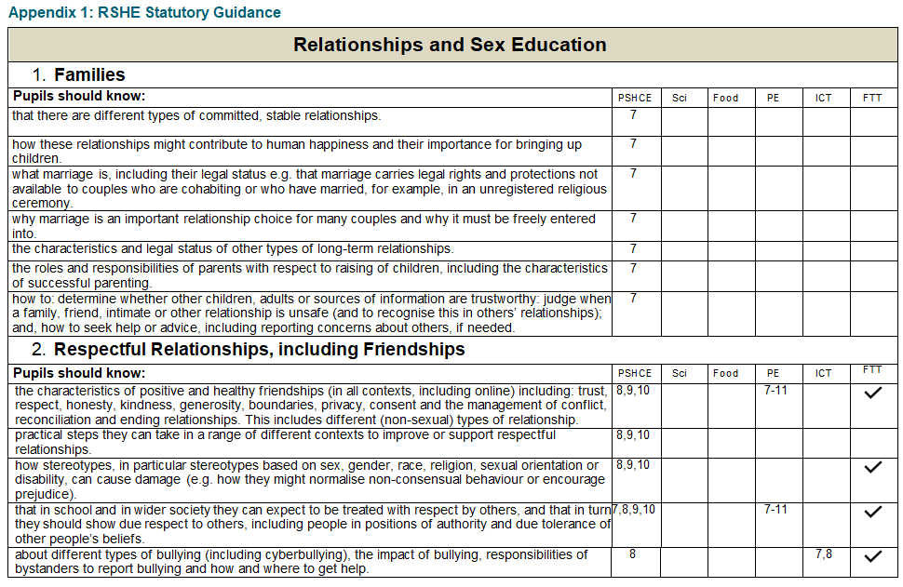
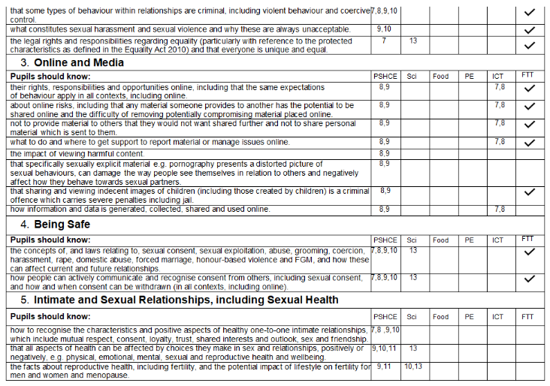

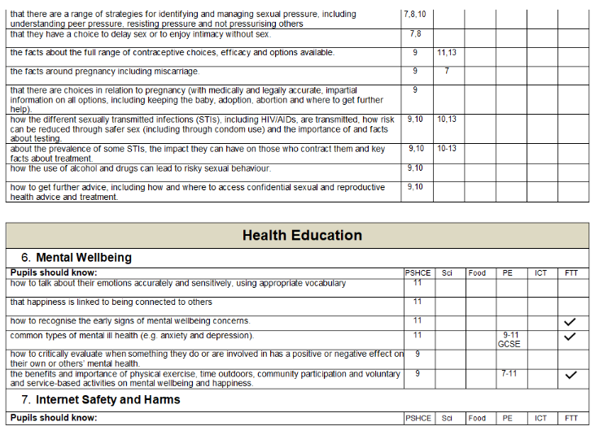
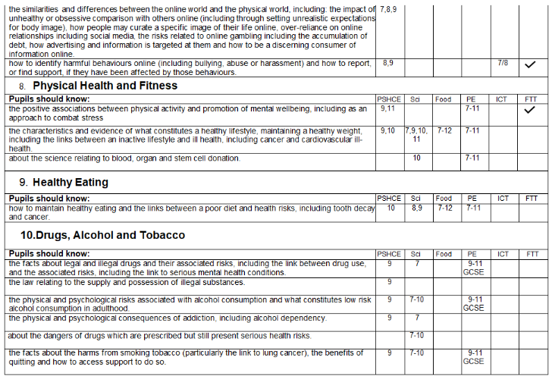

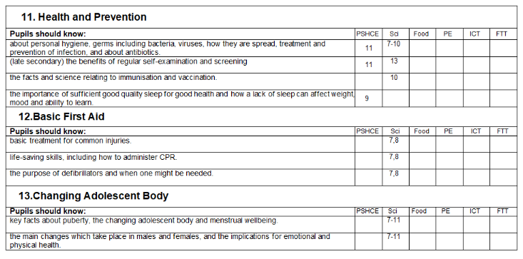

Appendix 2: Parent form for withdrawal from sex education

To be completed by parents
Name of child |  | Class
Name of parent |  | Date
Reason for withdrawing from sex education within relationships and sex education
Any other information you would like the school to consider
Parent signature

To be completed by the school
Agreed actions from discussion with parents

