

Attendance Policy
Head
22 September 2025

Document Control Table
Document title: |  |  |  | Attendance Policy
Author (name & job title): |  |  |  | Head
Version number: |  |  |  | 1
Date approved: |  |  |  | 18.6.25
Approved by: |  |  |  | QoE
Date of review: |  |  |  | 30.4.26
Document History
Version | Date | Review | Author |  | Note of revisions
1 | 18.6.25 | 30.4.26 | Mandy Stocks |  | Change of author

Table of Contents
OUR ETHOS 4
ATTENDANCE EXPECTATIONS 5
REPORTING UNPLANNED ABSENCE (SUCH AS SICKNESS) 6
HOW DO I DECIDE IF MY CHILD IS TOO ILL TO COME TO SCHOOL? 6
PLANNED ABSENCES (SUCH AS MEDICAL APPOINTMENTS) 7
REQUEST FOR LEAVE OF ABSENCE 7
MISSING CHILDREN 8
NATIONAL FRAMEWORK FOR PENALTY NOTICES 8
MONITORING AND SUPPORTING EXCELLENT ATTENDANCE 9
REDUCING PERSISENT AND SEVERE ABSENCE 9
HOME VISITS 11
ATTENDANCE CONCERNS 11

OUR ETHOS

At the Elizabethan Academy our aim is to work together with parents and carers to ensure that all our pupils receive the most from their education and reach their full potential. We promote exceptional attendance, expecting all students to be in school for at least 184/190 (97%) days and strive to achieve the maximum number of days of 190. (100%)
Our unwavering commitment to attendance puts our students at the centre of the process, using evidence-informed practices and creating a shared understanding of everyone's roles and collective responsibilities. We will work with the student and their family to reduce barriers to attendance and seek to offer support to ensure the student is successful at school, working as a partnership, school, student and the family. Therefore, At the Elizabethan Academy we will reach out and offer support to any pupils who are on track to be persistently absent (PA) and will not wait until attendance is below 90%. We know that the foundation to excellent attendance is a high quality education, delivered in a calm, safe and supportive environment in which all students want to attend and can learn and thrive.
Regular attendance to school can have a significant impact on:
• Academic Achievement: Regular attendance directly correlates with academic success. Children who attend school consistently are more likely to keep up with the curriculum, perform better in exams, and improve their life outcomes.
• Knowledge Acquisition: School is where children acquire knowledge and skills that are crucial for their personal and professional growth. Missing days means missing out on valuable learning opportunities.
• Social Development: School provides a vital social environment for children to interact with peers, develop friendships, and learn essential social skills. Consistent attendance ensures children remain connected to their peer group.
• Building Routine: School attendance establishes a structured routine in children’s lives, teaching them time management and responsibility, which are valuable life skills.
• Teacher Interaction: Regular attendance allows for meaningful teacher-child interactions. Teachers can provide personalised support, address questions, and assess individual progress more effectively when children attend regularly.
• Preventing Knowledge Gaps: Frequent absences can lead to significant knowledge gaps, making it challenging for children to catch up with missed lessons, potentially resulting in long-term academic struggles.
• School Engagement: Children who attend school regularly are more likely to engage in extra-curricular activities, and other enriching experiences that contribute to their overall development.
• Legal and Parental Responsibility: Families are legally responsible for ensuring their child's regular school attendance. Failing to do so can lead to legal consequences.
• Community Wellbeing: High levels of school attendance contribute to the overall well-being of communities.
The aim of this policy is to set out how we create and maintain a positive culture that supports and values exceptional attendance.
It includes how we:
• Promote exceptional attendance and punctuality
• Follow up absences
• Communicate and work with families to reduce absence
• Monitor absences and analyse patterns of absence
• Work with local partners to support exceptional attendance and reduce absences
Punctuality expectations
● Students should be on site by 8:35am.
● The first bell rings at 8:35am, signalling that students should move promptly to their tutor rooms.
● A second bell rings at 8:40am, marking the official start of the registration period.
● Senior leaders will close the school gate at 8:40am. Any student arriving after this time will be recorded as late and issued a break time detention in IT1 on the same day.
Students who arrive after 9:10am will receive an unauthorised absence mark for the morning session, in line with Department for Education guidance.
Students whose bus arrives late, or are late for other unavoidable reasons, will not be sanctioned.

ATTENDANCE EXPECTATIONS
At the Elizabethan Academy we promote exceptional attendance, expecting all students to be in school for at least 184/190 (97%) days and strive to achieve the maximum number of days of 190. (100%)
●The Academy day begins at 8.40am. Students are expected to be in the Academy by 8.35am and to be in tutor time by 8.40am.
●The AM register opens at 8.40 am and lasts for 30 minutes.
●If a student arrives after 9.10 am, when the AM register has closed, they will receive an unauthorised absence for the AM session. This is in line with updated government guidance.
●The PM register opens at 1.15pm and lasts for 30 minutes. If a student arrives after 1.45pm they will receive an unauthorised absence for the PM session.

REPORTING UNPLANNED ABSENCE (SUCH AS SICKNESS)
Any absence should be reported by 8am each day that the student will be absent through the Arbour App, or by calling 01777 713700 (option 2). Please ensure to state the full name of your child, their year group and give details regarding the reason for absence.
We will mark absence due to illness as authorised unless the academy has a genuine concern about the authenticity of the illness, or the student is under attendance monitoring. If the authenticity of the illness is in doubt, or the student is under attendance monitoring, the academy may ask the student’s family to provide medical evidence, such as a doctor’s note, prescription, appointment card or other appropriate form of evidence. We will not ask for medical evidence unnecessarily. If the academy is not satisfied about the authenticity of the illness, the absence will be recorded as unauthorised and families will be notified of this in advance.
If your child’s attendance is broken by regular absence due to minor illnesses (broken
weeks) we will write to you to advise you that any further absences will not be authorised
without medical evidence. In these circumstances reporting your child ill will no longer be sufficient to authorise the absence.
Where there is a pattern of repeated, frequent absences over a long period of time, further
information will be required in order to authorise the absences. In cases where there is no
known medical reason for the frequency of absence reported as ‘illness’ the school will
seek clarification from a health professional that they are aware of the absences and verify
that these should be authorised.
The Elizabethan Academy will not authorise absences for any of the following reasons:
• Term-time holidays (including visiting family abroad)
• Study leave
• Trivial illnesses
• Looking after siblings, including dropping them off at school or nursery
• Being unhappy or not getting on with other students in school
• Being up late the night before

HOW DO I DECIDE IF MY CHILD IS TOO ILL TO COME TO SCHOOL?
We ask that you consider the following when deciding with your child if they are well enough for school:
- Would it be appropriate to notify the school that my child has a minor illness and ask them to monitor throughout the day?
- Is it appropriate to take painkillers and then attend school? (eg With headaches, colds or period pain)
- Would I take the day off work for this illness?
- Is my child suitably looked after at home when absent from school?
The NHS website can give helpful advice when making the decision ‘is my child too ill to go to school?’
https://www.nhs.uk/Livewell/Yourchildatschool/Pages/Illness.aspx

PLANNED ABSENCES (SUCH AS MEDICAL APPOINTMENTS)
We encourage families to make medical and dental appointments out of school hours where possible. Where medical appointments cannot be scheduled outside school hours, the attendance team should be made aware in advance by emailing attendance@elizabethan.notts.sch.uk. Students should attend school prior to their appointment, and return promptly afterwards as only the time for the appointment and travel will be able to be authorised

REQUEST FOR LEAVE OF ABSENCE
Working together to improve school attendance advises all schools that they should only grant a leave of absence during term time in exceptional circumstances, considering each request on a case-by-case basis. Although we recognise the value and benefits of family holidays, requests for absences of this nature will not be granted as the Government ‘does not consider a need or desire for a holiday or other absence for the purpose of leisure and recreation to be an exceptional circumstance.’
This guidance is to remind all parents/carers about the law that requires them to ensure that their child attends school daily during term time. The Government is clear that no child should miss school apart from in exceptional circumstances and schools must take steps to reduce absence to support children’s attainment.
A leave of absence is granted at the Principal’s discretion, including the length of time the student is authorised to be absent for.
We define ‘exceptional circumstances’ as but not limited to:
• Death or serious illness of a parent or sibling.
• Return of a parent from active service (forces).
• Participation in approved public performances/sporting competitions.
Any request should be submitted to the attendance team (attendance@elizabethan.notts.sch.uk) as soon as it is anticipated and, where possible, at least two weeks before the absence. Evidence may be required to support any request for leave of absence.

MISSING CHILDREN

After 5 days of absence and continued non-response, the academy will issue a potential holiday letter.
If no notification has been received from families regarding their child’s absence after 10 school days, the academy will report the child as ‘missing from education’ to the Local Authority for them to immediately investigate.

NATIONAL FRAMEWORK FOR PENALTY NOTICES
There is now a single consistent national threshold for when a penalty notice must be considered by all schools in England, of 10 sessions (usually equivalent to 5 school days) of unauthorised absence within a rolling 10 school week period. The 10 sessions of absence do not have to be consecutive and can be made up of a combination of any type of unauthorised absence (G, O and/or U coded within the school’s registers). The 10-school week period can span different terms, school years or education settings.
Sanctions may include issuing each parent/guardian (for each child) with a Penalty Notice for £160, reduced to £80 if paid within 21 days (for the first offence).
A second Penalty Notice issued within a three-year period will result in a fine of £160 per parent/guardian, per child.
If a third offence is committed the matter may be referred to the local authority for consideration of prosecution via the Magistrates Court.
If prosecution is instigated for irregular school attendance, each parent/guardian may receive a fine of up to £2500 and/or up to 3 months in prison. If a parent/guardian is found guilty in court, they will receive a criminal conviction.
There is no entitlement in law for pupils/students to take time off during the term to go on holiday or other absence for the purpose of leisure or recreation, or to take part in protest activity in school hours. In addition, the Supreme Court has ruled that the definition of regular school attendance is “in accordance with the rules prescribed by the school.”
The School Attendance (pupil Registration) (England) Regulations 2024 set out the statutory requirements for schools. All references to family holidays and extended leave have been removed. The amendments specify that the Principal may not grant any leave of absence during term time unless there are "exceptional circumstances" and they do not have any discretion to authorise up to ten days of absence each academic year

MONITORING AND SUPPORTING EXCELLENT ATTENDANCE
Regular and punctual attendance at school is a legal requirement, as well as being essential to enable children to maximise their educational attainments and opportunities. “The parent of every child of compulsory school age shall cause him/her to receive efficient full time education either by regular attendance at school or otherwise”. (Education Act 1996)
“If a child of compulsory school age who is a registered student at a school full-time attend regularly at the school his parent is guilty of an offence”.
At the Elizabethan we have a child centred approach, understanding the barriers to attendance that may be faced by students and parents, through no fault of their own. A three-tiered support approach is implemented in order to support students to overcome these barriers.
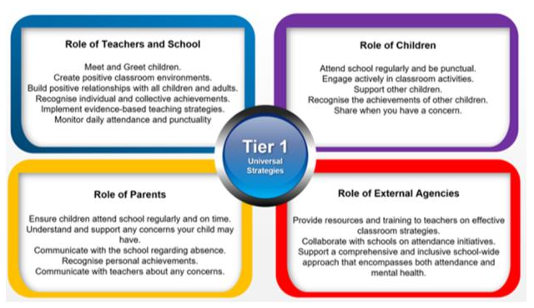

REDUCING PERSISENT AND SEVERE ABSENCE
Persistent absence is where a student misses 19 or more days of school (below 90% attendance)
Severe absence is where a student misses 95 or more days of school (below 50% attendance).
To support students in attending school, the Elizabethan Academy will:
● Use attendance data to find patterns and trends of persistent and severe absence.
● Communicate regularly with parents/carers regarding their child's attendance.
● Intervene at an early stage (students with an attendance of 95% or below) to identify and address barriers to attendance.
● Hold regular meetings with the families of students who the academy (and/or local authority) considers to be vulnerable, at risk of or persistently or severely absent to discuss attendance and engagement at school.
● Provide access to wider support services to remove the barriers to attendance such as Early Help.
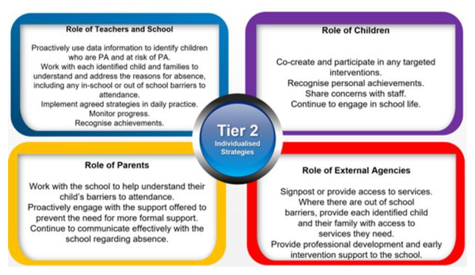
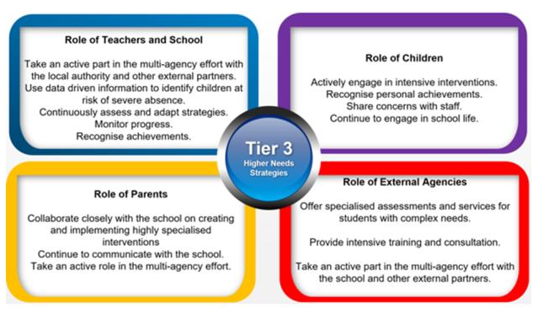

HOME VISITS
These visits are to strengthen relationships and offer support in reducing barriers to absence as well as listening to both students and family voice. Working together enables us to ensure we are signposting families to the most appropriate external agency that can offer support. Home visits are also completed as part of our safe and welfare checks and should be seen as a supportive measure.

ATTENDANCE CONCERNS
If you have any concerns about your child's attendance please reach out to their Tutor, Head of Year, our attendance team (attendance@elizabethan.notts.sch.uk) or the Senior Attendance Champion (Ms A.Stocks). It is only by working together that we can support each individual to succeed.



