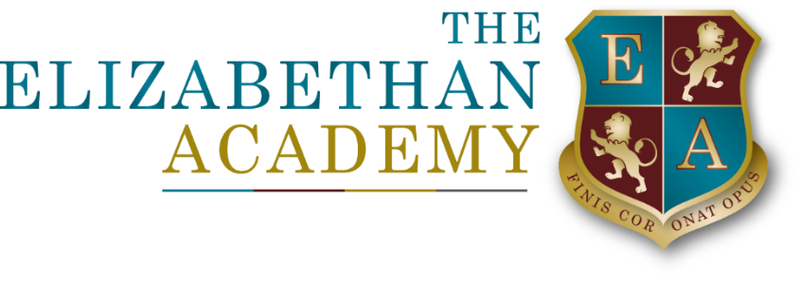

The Elizabethan Academy Transport Policy
C d'Albuquerque CFOO
June 2025

Document Control Table
Document title: |  |  |  | The Elizabethan Academy Transport Policy
Author (name & job title): |  |  |  | C d'Albuquerque CFOO
Version number: |  |  |  | 1
Date approved: |  |  |  | June 2025
Approved by: |  |  |  | Principal
Date of review: |  |  |  | June 2026
Document History
Version | Date | Review | Author |  | Note of revisions
1 | June 2025 | New | C d’Albuquerque

Table of Contents
1. Purpose and Scope 4
2. Full-Week Travel Passes 4
3. Partial-Week Travel (Discretionary) 4
4. Behaviour and Conduct 4
5. Free Transport Provision 4
6. Limited Service Provision 4
7. Payment Mechanism 4

1. Purpose and Scope
This policy outlines the principles and conditions under which The Elizabethan Academy provides access to school transport services. It applies to all students who use or apply to use Academy-arranged transport.
The Academy recognises that many families have chosen to exercise their right to send their child to a preferred school, rather than the nearest qualifying school. In support of this choice, the Academy provides a limited number of transport services. These services are not provided free of charge and are funded through parental contributions.

2. Full-Week Travel Passes
• Bus passes issued by the Academy are valid for full-week travel only (Monday to Friday).
• These passes are non-transferable and are valid only for the designated route and times.
• Bus passes may be issued for students attending the academies sixth form subject to availability and capacity on the services.

3. Partial-Week Travel (Discretionary)
• Where a service has spare capacity, the Academy may offer partial-week travel passes (e.g., for specific days).
• These passes are issued at the sole discretion of the Academy and are subject to ongoing availability.
• The Academy reserves the right to withdraw or refuse partial-week passes at any time if capacity becomes limited.
• Bus passes may be issued for students attending the academies sixth form subject to availability and capacity on the services.

4. Behaviour and Conduct
• Students are expected to uphold the Academy’s standards of behaviour while using transport services.
• Transport access may be withdrawn if a student’s behaviour falls below expectations.
• No refunds will be issued in cases where transport access is withdrawn due to behavioural issues.

5. Free Transport Provision
• Free transport is only provided in accordance with the Nottinghamshire County Council’s Home to School Transport Policy.
• Eligibility for free transport is determined by the local authority, not the Academy.
• For full details, please refer to the Nottinghamshire County Council Transport Policy.

6. Limited Service Provision
• The Academy operates a limited number of transport services.
• These services are reviewed regularly and may be withdrawn with no less than one year’s notice.
• Parents and carers are advised to make contingency plans in the event of service changes.

7. Payment Mechanism
• Transport services provided by the Academy are chargeable.
• A request for payment will be issued annually via iPay.
• Payments are due termly in advance, according to the following schedule:
- July (for the Autumn Term)
- November (for the Spring Term)
- April (for the Summer Term)
• Failure to make timely payments may result in the withdrawal of transport access.

