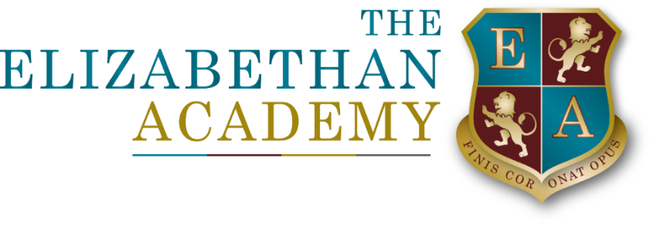

Careers Policy
Lee Dainty
19 May 2025

Document Control Table
Document title: |  |  |  | Careers Policy
Author (name & job title): |  |  |  | Lee Dainty
Version number: |  |  |  | 2
Date approved:
Approved by:
Date of review:
Document History
Version | Date | Review | Author |  | Note of revisions
2 | 27.2.25 | 27.11.26 | Lee Dainty

Table of Contents
1. Aims 4
2. Statuatory Requirements 4
3.Provision 5
4. Monitoring, Recording and Evaluation 6
5. Partnerships 7

Aims

The Elizabethan Academy’s careers programme provides pupils with the opportunity to plan and manage their careers effectively, ensuring progression routes which are ambitious, aspirational but achievable. It promotes equality of opportunity, celebrates diversity and challenges stereotypes. It is designed to meet the Gatsby benchmarks and conforms to statutory requirements. We ensure that appropriate advice, guidance and information are available in Years 7 to 13 through a careers programme which is embedded into the curriculum and includes a variety of enrichment activities.

We aim to ensure that all pupils:
- develop the skills and attitudes necessary for success in adult and working life
- develop an awareness of the wide variety of education, training and careers opportunities both locally and nationally
- are supported in making informed decisions which are suitable and ambitious
- benefit from links fostered between the school, local businesses and further education establishments
- experience the world of work and develop transferable skills
- are equipped with the necessary skills to manage transitions
- leave the school to enter employment, further education or training
- experience a culture of high aspirations and equality of opportunity, in which diversity is celebrated, and stereotypes are challenged
- receive extra assistance and guidance to reach their potential, where this is necessary

Statuatory Requirements
The careers provision at the Elizabethan Academy meets the statutory guidance which states that all schools should provide independent careers guidance from Years 7 -13 and that this guidance should:
- be impartial
- include information on a range of pathways, including university options or apprenticeships
- be adapted to the needs to the student
The school’s programme of careers education, information and guidance has also been developed to meet the eight Gatsby benchmarks which ensure best practice:

The Gatsby Benchmarks
- A stable careers programme
- Learning from career and labour market information
- Addressing the needs of each student
- Linking curriculum learning to careers
- Encounters with employers and employees
- Experience of workplaces
- Encounters with further and higher education
- Personal guidance

In addition, the school is compliant with the careers guidance that the government set out for delivery from 5 January 2018: ‘Careers Guidance and Inspiration for young people in schools.’ This states that all academies must give education and training providers the opportunity to talk to students about approved technical qualifications and apprenticeships. (Further information can be found in the Provider Access Policy.)

ProvisioN
Careers provision is mapped against the Gatsby benchmarks.
All students have access to:
- Enrichment activities built into the timetabled week that are designed to develop oneself.
- Extra-curricular clubs and trips which support them in developing understanding of the world of work and the opportunities open to them beyond school in education and training e.g. a visit to a university or college.
- Carefully managed options and transition processes in Y8, Y11 and Y13 which ensure students have a wide range of information to support them in their choices and future pathways
- The careers office including a range of literature and resources, the careers section of the website, and personal careers guidance and support from Progress Careers
- Assemblies and the weekly Pastoral Briefing which share information about careers, celebrate achievements and highlight opportunities available beyond school
- National Careers Week at the beginning of March which includes talks to students about apprenticeships, stereotypes in the workplace etc. Visitors are invited in and the school makes use of companies such as Rolls Royce
Students with Special Educational Needs or Disabilities
- Transition from one key stage to the next, and onto careers or training, is carefully managed for students with SEND
- Personalised support is given to vulnerable students alongside use of external agencies
KS3
- The PSHCE programme in Y7, Y8 and Y9 includes Schemes of Learning on careers, and covers a wide range of topics such as: future careers, business organisation, labour market information, employability skills, working life, career action plans, pay and tax.
- The option process in Y8 is designed to encourage students to consider future pathways and career goals when making choices about their GCSEs
- Pastoral activities in Form Tutor Time and through the House system ensure students are aware of wider issues such as economic well-being, citizenship and enterprise
KS4
- Students continue research into careers and pathways post-16 supported by assemblies on the options available and parent information evenings
- They develop skills in CV, letter writing, presentations and interviews
- Students take part in a week’s work experience at the end of Y10 (See Work Experience Policy). Placements are largely arranged by the students themselves with support as required.
- Attendance at regional careers fairs
- A mock interview day in Y11 allows all students to experience a real-life situation of preparing and completing an interview with a local employer
- All students receive an individual careers interview with Progress Careers and a follow-up meeting if required
- Any students at risk of becoming NEETs are supported intensively with frequent contact between school, home and external agencies
KS5
- Sixth form tutors support students with post- 19 choices
- Form Tutor Time is devoted to UCAS applications and preparing for university interviews
- Students wishing to apply for Oxbridge are supported by the Scholars Programme
- Students are also involved in voluntary, community and charity work
- Students take part in a week’s work experience at the end of Y12
All staff contribute to the implementation of this policy through their role as tutors and as subject specialists. Curriculum areas aim to embed careers into their subject delivery and raise awareness of the world of work in their Schemes of Learning. Curriculum Intent Maps in all Faculties across KS3-5 must include elements of the wider world in their planning and delivery.

4. Monitoring, Recording and Evaluation

Built into the careers programme are opportunities for pupils to self-evaluate and reflect on their learning at key points such as following work experience or after the mock interviews during Y11.
The following QA is completed:
- Destinations data for Y11 and Y13
- NEETs analysis
- Link governor updates
- Stakeholder feedback
- Parental feedback
- Teacher feedback
- QA of CIMs

5. Partnerships
The school CEIAG programme is greatly enhanced through links which ensure pupils’ learning is current and relevant. On average over 150 local employers offer placements to students each year for their work experience; around 20 employers offer their time and experience each year on the mock interview day.
The school works closely with a range of local employers, businesses and organisations to provide one-to-one careers talks, in school and online sessions, specialist mentoring, work placements etc. Partnerships include:
- Alumni (Lead – Lee Dainty)
- Armed Forces
- Cambridge University
- Decisions Magazine
- Doncaster College
- Doncaster New College
- Family Services
- Get-Ahead Training
- Her Majesty’s Revenue and Customs
- Inspire
- Job Centre Plus
- Lincoln College
- Lincoln University and Medical School
- National Careers Service
- NHS
- North Notts College
- Nottingham Training Group
- Nottingham Trent University
- Police Cadets
- Retford Motor Vehicle College
- Sheffield Hallam University
- STEM Ambassadors
- The Ask Team
- The Food Bank
- University of Sheffield
- Youth Parliam

