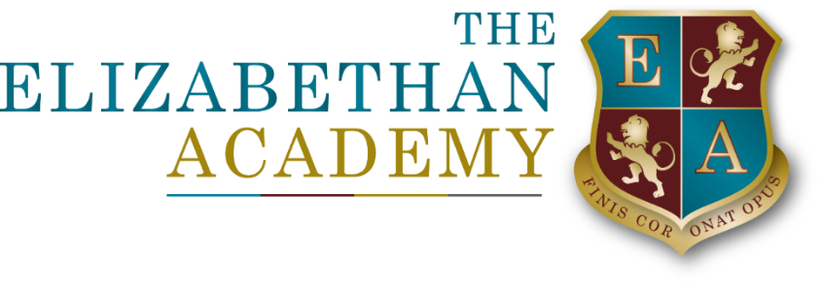

Parents, Carers and Visitors Code of Conduct
Mrs Upson
15 May 2025

Document Control Table
Document title: |  |  |  | Parents, Carers and Visitors Code of Conduct
Author (name & job title): |  |  |  | Mrs Upson
Version number: |  |  |  | 1.2
Date approved: |  |  |  | March 2025
Approved by: |  |  |  | Finance and Resources
Date of review: |  |  |  | March 2027
Document History
Version | Date | Review | Author |  | Note of revisions
1.0 | Nov 2020 |  | HU
1.1 | June 2023 |  | HU |  | Minor Changes
1.2 | March 2025 |  | HU |  | Minor updates and simplification

Table of Contents
1. Statement of principles 4
2. Our expectations of parents and carers and visitors 4
3. Behaviour that will not be tolerated 4
4. Breaching the code of conduct 5
5. Removal from school 5
6. Complaints Policy 5
7. Further Action by staff 5

1. Statement of principles
1.1 At the Elizabethan Academy, we value the positive relationships forged with parents and visitors to the Academy. We encourage close links with parents and the community and believe that students benefit when the relationship between home and the Academy is a positive one. We also strive to make our Academy a place where, as adults we model for students the behaviour we teach and expect. In general, we place a high importance on good manners, positive communication and mutual respect.
NOTE: Any reference to parent within this Policy means any person with parental responsibility. Whilst the process below uses the term “parent” the process may equally be applied to any parent, carer, relative or other visitor to our school.

2. Our expectations of parents and carers and visitors
2.1 We expect parents, carers and other visitors to:
- Respect the ethos, vision and values of our Academy
- Work together with staff in the best interests of our pupils
- Treat all members of the Academy community with respect – setting a good example with speech and behaviour
- Seek a peaceful solution to all issues
- Correct their own child’s behaviour (or those in their care), particularly in public, where it could lead to conflict, aggression or unsafe conduct
- Approach the right member of Academy staff to help resolve any issues of concern

3. Behaviour that will not be tolerated
- We consider that aggressive, abusive or insulting behaviour or language from a parent presents a risk to staff or students. Unacceptable behaviour is such that makes a member of staff or student feel threatened. This can be through face-to-face contact, on the telephone or in written communication (including social media). The following is not an exhaustive list but seeks to provide illustrations of such behaviour:
- Any kind of threat
- Any kind of insult as an attempt to demean, embarrass or undermine
- Displaying a temper, or shouting at member of staff, pupils or other parents
- Raising of voice so as to be intimidating
    - Physical intimidation, e.g. by standing very close to individuals or the use of aggressive hand gestures
    - Any aggressive behaviour (including verbally or in writing) toward another child or adult
- Taking photos or videos of staff or students on the Academy premises
- Use of foul or abusive language and/or any kind of physical abuse.
- Allegations which turn out to be vexatious or malicious.
- Approaching someone else’s child to chastise them
- Abusive telephone calls, emails and letters.
- Posting defamatory, offensive or derogatory comments about the Academy, its staff or any member of its community, on social media
- Sending abusive message to another member of the Academy community, including via text, email or social media

Breaching the code of conduct
- If the Academy suspects, or becomes aware, that a parent has breached the code of conduct, the Academy will gather information from those involved and may speak to the parent about the incident.
Depending on the nature of the incident, the Academy may then:
- Send a warning letter to the parent
- Invite the parent into the Academy to meet with a senior member of staff or the Principal
- Contact the appropriate authorities (in cases of criminal behaviour)
- Seek legal advice regarding further action (in cases of conduct that may be libellous or slanderous)
- Ban the parent from the Academy site
The Academy will always respond to an incident in a proportional way. The final decision for how to respond to breaches of the code of conduct rests with the Principal
The Principal will consult the chair of governors before banning a parent from the Academy site.

5. Removal from school
  - Parents who have been banned from the Academy premises and continue to cause a nuisance will be deemed to have committed a section 547 offence under the Education Act 1996. They will be considered as trespassers. In these circumstances the offender may be removed from the Academy. This may be carried out by a police officer or person authorised by the Governing Body. Legal proceedings may be brought against the parent. The police may also be involved if the Principal deems it appropriate.

6. Complaints Policy
- Any parental complaint that arises from incidents of abusive behaviour will be dealt with under the Complaints Policy available on our website

7. Further Action by staff
- Should staff be dissatisfied with the resolution of the matter under this policy they are invited to discuss the matter informally with the Principal, if such action does not provide a satisfactory resolution, they are referred to the Grievance Policy and processes contained therein.

