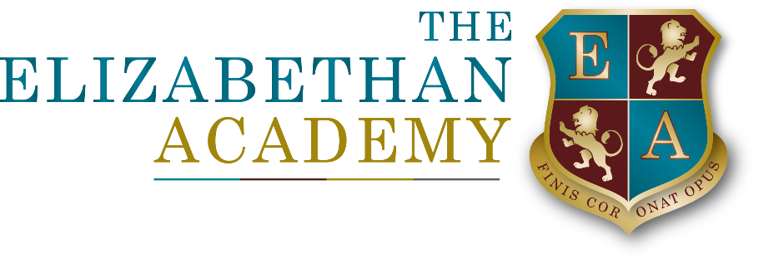

Parental consent form

Under the General Data Protection Regulations (GDPR) which came into effect on 25 May 2018, all organisations are required to ensure, when they process certain types of personal data and information, that consent has been given and recorded. It is, therefore, really important to us, for you to complete and return this form to: The Office Manager in the Main Office at The Elizabethan Academy.

The information in this form will be used throughout your child’s time at The Elizabethan Academy. You may withdraw your consent at any time by contacting: The Office Manager in the Main Office.

Student information

Student
Name
Year
Class

Parent/carer
Name
Relationship to student
Address
Phone
Mobile
Email

Please indicate whether you have given your consent in each case by ticking the box on the right-hand side; and sign and date the form on the last page.

On-site activities

I give my permission for my son/daughter to:
Use the internet in line with The Elizabethan Academy’s acceptable usage policy
Access online applications in line with The Elizabethan Academy’s acceptable use policy to assist with learning
View films and video clips rated PG
Attend after-school clubs
Take part in food preparation/cooking and tasting activities

Please outline any food allergies/specific dietary requirements:

.................................................................................................................................................................
.................................................................................................................................................................

Off-site activities

I give my permission for my son/daughter to take part in:
Supervised visits to local destinations away from the main Elizabethan Academy site
Supervised one-day non-residential visits within the UK
Supervised off-site activities (for example, sporting fixtures and swimming lessons)

Please note: In addition to providing consent using this form, The Elizabethan Academy always requests that a specific form is also completed in the event that your child should wish to participate in any off site activities.

Medical consent

I give my permission for:
My son/daughter to be given first aid by a trained member of staff during any on-site or off-site activity
My son/daughter to receive urgent dental, medical or surgical treatment, including anaesthetics, as may be considered necessary by the medical authorities present, during any on-site or off-site activity
My son/daughter’s information to be shared with the NHS and other relevant health professionals
A member of Elizabethan Academy staff to sign on my behalf any medical consent forms, if my son/daughter should require emergency treatment and I cannot be contacted
Plasters to be applied to my son/daughter
My son/daughter to use anti-bacterial hand gel
My son/daughter to be assisted in applying sunscreen if necessary
Staff to administer the medicines I have listed below:
.......................................................................................................................................................

Please outline any medical conditions/allergies:

..................................................................................................................................................................
..................................................................................................................................................................

Emergency release

I give my consent for my son/daughter to be released to the following person(s) in the event of emergency or illness, if I cannot be contacted:
Person 1
Name
Address
Relationship to student
Contact number

Person 2
Name
Address
Relationship to student
Contact number

Use of information and image (including photographs and video recordings)

Please note: We like to take photographs and videos of our students to use for a variety of reasons such as celebrating their achievements for marketing purposes, for example academy prospectus, newsletters, academy website, academy publications, social media, press releases and archive records. In order to comply with GDPR, we are required to seek the permission of parents and carers before recording such images.

I give my permission for my son/daughter’s:
Name to be used on The Elizabethan Academy website, printed publications and local media
Work to be used in displays and on The Elizabethan Academy website
Image to be used within The Elizabethan Academy (for example, in wall-mounted displays)
Image to be used in printed publications (for example, The Elizabethan Academy prospectus)
Image to be used on social media sites which The Elizabethan Academy uses for the purpose of providing information and marketing
Image to be used on The Elizabethan Academy website and in the local media
Image to be used in communication with international pen pals
Image to be taken by, or used in circulation to, other parents (for example, events)

Please note: Fingerprint scans & biometric data – we operate a fingerprint system for meals and taking out library books. This has many advantages. It saves your child from carrying cash every day as you can pay on line. You can be confident that they are spending money on meals and not in the local shop. You can also monitor online what they are eating and keep an eye on a healthy diet. Pupils have their fingerprint registered on the system which is then translated into letters and numbers. The letters and numbers are then used by the system to identify the child. Please note that if a student is unhappy with biometric data being used then they can request to use a card as an alternative method. The cost for this, and subsequent replacement cards if it is lost, is £5.

I give my permission for my son/daughter’s:
Biometric data (for example, fingerprints) to be processed

Communication

I give my permission for The Elizabethan Academy to contact me via:
Phone
Email
Text message

The Elizabethan Academy Privacy Notice for Parents:

I confirm that I have received a copy of The Elizabethan Academy Privacy Notice for Parents and have read and understand the content.

Please sign and date the form before returning it to: The Office Manager in the Main Office:

Signed: ................................................................................ Date: ..............................................

