Fact or Opinion?

In life, it is important to know the difference between fact and opinion.

Activity:

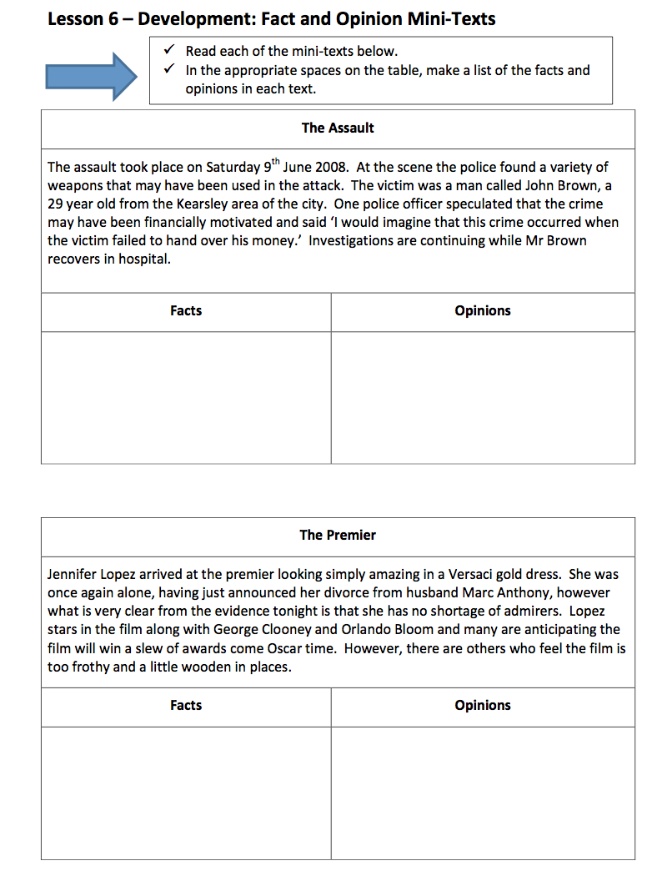

Identifying Bias

Bias is a strong opinion about something.
You can be biased in favour of something or biased against it.
In either case, you may have some facts to support your position, but bias is based more on feelings and opinions than on facts.

You can work out a writer’s point of view by finding words that reveal their feelings (‘I feel’, ‘I love’, ‘it’s terrible’, ‘it’s wonderful’); beliefs (‘should’, ‘ought’, ‘must’, ‘need to’); thoughts (‘I think’, ‘in my opinion’, ‘I agree with’, ‘most people think’).

A balanced view of a topic includes different points of view. A writer who only gives one side of the argument is showing bias.

Look for language that has bias, one way or the other.

Reading Between the Lines

Sometimes a writer will try to influence the reader by only giving their opinion.

- A text might exaggerate something, or ignore the other side of the argument. For example: North Coast Trains is the worst train company in Britain – this is someone’s opinion and not everyone may agree with it.

- A text might include humour to entertain the reader. For example: The new Hadawi sports car is the worst car I’ve ever driven. The engine is pathetic – I think my three-legged tortoise could probably move faster.

- A biased text might use strong language to make the reader agree with the writer. For example: My meal was dreadful – the meat was disgusting.

- A text might show a writer’s feelings about something. For example: I am increasingly concerned about the drop in numbers attending Estrick Leisure Centre; this is very worrying and fills me with dismay.

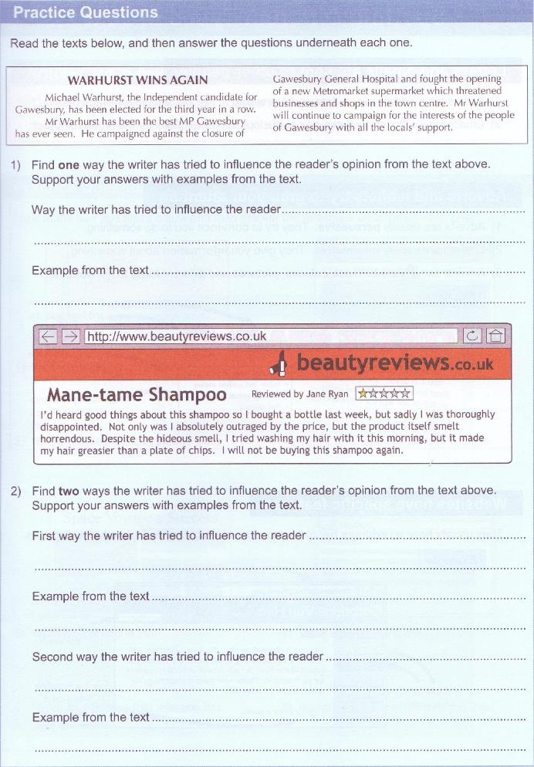
Practice reading question:

Read the following article and answer questions 1-5.

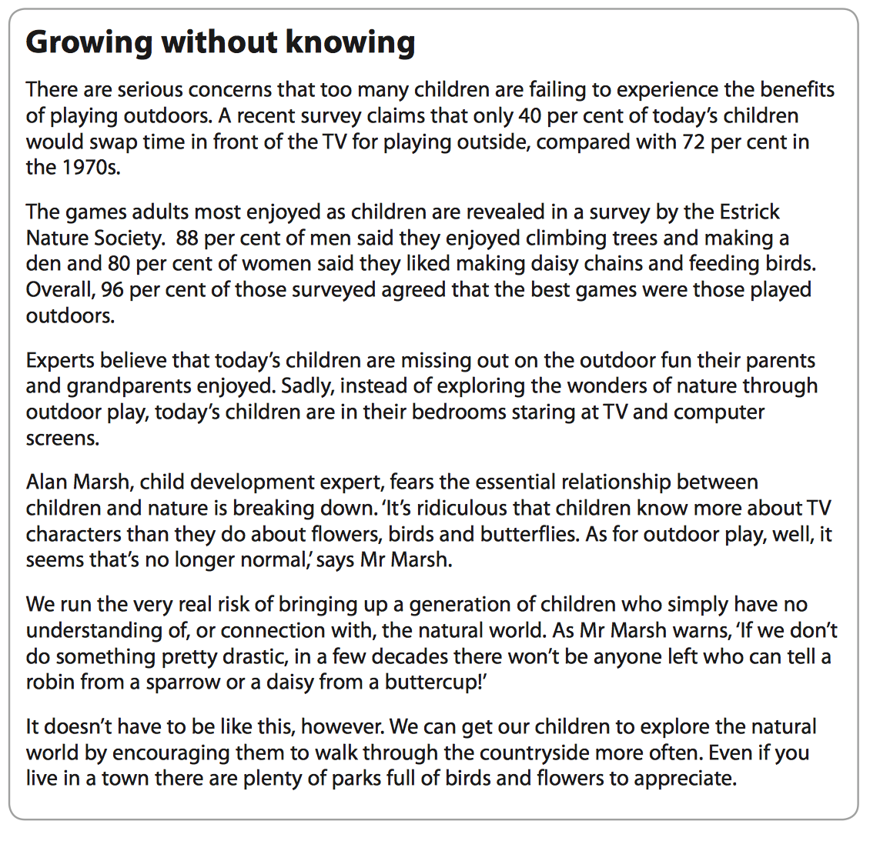

(Jan 2013)

- What is the main purpose of the text?

______________________________________________________________________________________________________________________

- What percentage of children would prefer to play outdoors rather than watch TV?
☐ A 40%
☐ B 72%
☐ C 80%
☐ D 88%

- According to the text, when they were children:
☐ A 80% of women enjoyed making a den
☐ B 80% of men enjoyed feeding birds
☐C 88% of men enjoyed climbing trees
☐ D 88% of women enjoyed making daisy-chains

- According to the text, state two things children could do to learn more about nature.

- ____________________________________________________________________________________________________________
- ____________________________________________________________________________________________________________

5. How does the writer of the text present a negative view of the way children play today? Give two examples.

- ____________________________________________________________________________________________________________
- ____________________________________________________________________________________________________________

How the writer conveys information

Features of the text can help convey information and also help you decide its purpose. For example, you could comment on layout:

- Headings – are they in bold?
- Subheadings
- Images such as photos or pictures
- Different font styles (e.g. Italic)
- Bullet points and numbered lists
- Numbered paragraphs
- Also comment on the use of persuasive language to engage the
reader; for example the use of the personal pronoun ‘you’.
- Punctuation – how is this effective in conveying information?
Bullet points
Heading in bold font

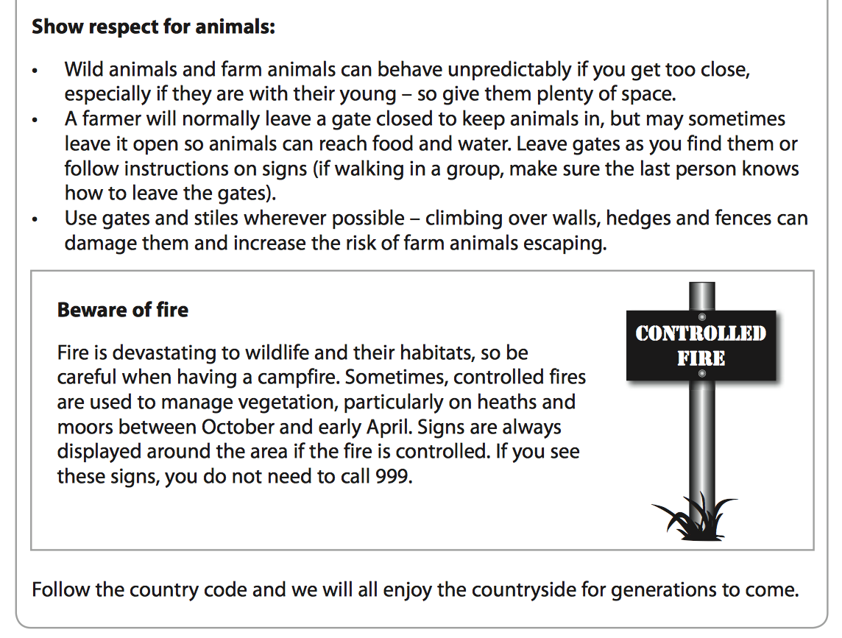

Image that relates to the text
Information / text in a box to make it stand out

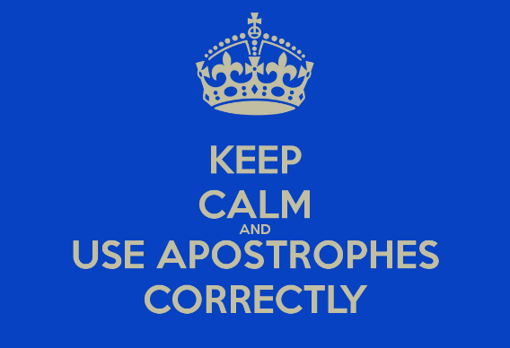

Sentence Structures

A simple sentence has a subject and a main verb.
I feel happy (‘I’ am the subject and ‘feel’ is the verb).

A compound sentence is a series of simple sentences joined together, usually with ‘and’ or ‘but’. For example: I feel happy and am enjoying spending time with my friends.

A complex sentence adds extra detail to a simple sentence (the main clause). For example: I feel happy and am enjoying spending time with my friends, who live in Dorset.

The main clause will make sense on its own but the extra detail will not.

A minor sentence is not really a sentence at all because it doesn’t have a main verb - Cup final. Well gutted!

Writing to suit purpose

What you write and how you write it should help you achieve your purpose.

- Read the task and find the key words which tell you about your purpose for writing (for example, inform, persuade, explain, instruct).

- Work out the content your writing should have to achieve its purpose (for example facts and evidence).

- Decide what style you need to use (for example, formal standard English, rhetorical questions, facts, opinions).

- Decide what presentation features to include (for example paragraphs, bullet points and lists, persuasive techniques.

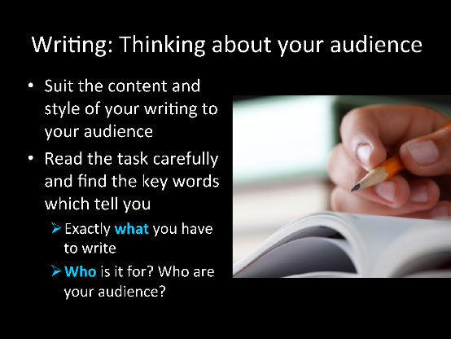

Writing Persuasively

Persuasive writing convinces the reader
to do something

You need to be persuasive in a lot of different types of writing.

- If you are writing an email asking for someone to make a guest appearance, or to sponsor a charity event, then you will need to be persuasive.

- In a letter of complaint you may try to persuade the reader to give you a refund or some form of compensation.

When you write to persuade you need to explain why the reader should do what you want them to. There are three appeals you can use in persuasive writing:

- Logical appeal – uses facts, statistics, data and expert opinion
- Emotional appeal – appeals to people’s emotions and feelings
- Moral appeal – convinces people that something is the right thing to do

For example:

Logical appeal – the facts and reasons
Did you know that the last decade has seen an 8% rise in the number of
animal testing procedures carried out in Britain? More than 100 million animals
every year die in laboratories as a result cosmetic, chemical, drug and food testing.

Emotional appeal – appeal to your reader’s heart using emotive language
Right now, millions of mice, rats, rabbits, primates, cats, dogs, and other animals are
locked inside cold, barren cages in laboratories across the country. They languish in
pain, ache with loneliness, and long to roam free and use their minds.

Moral appeal – convince your reader what is right
Each of us can help save animals from suffering and death in experiments by demanding that experiments on animals stop and by buying cruelty free products.
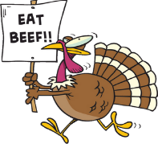
Using personal pronouns like you and your makes a text more persuasive.
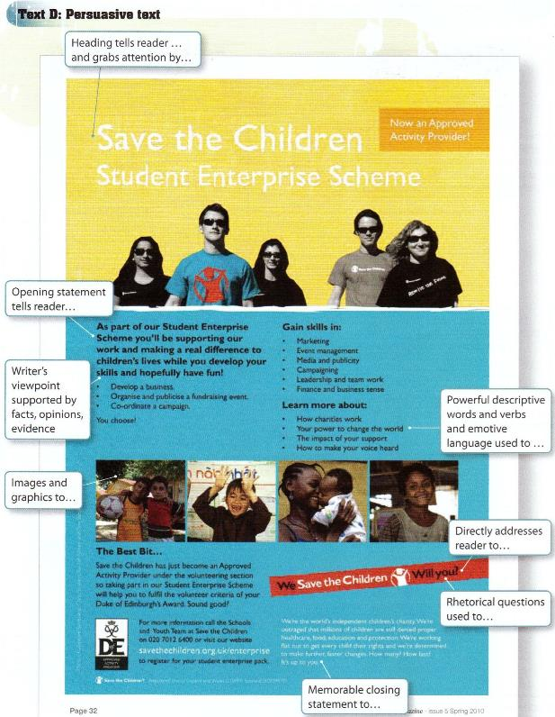
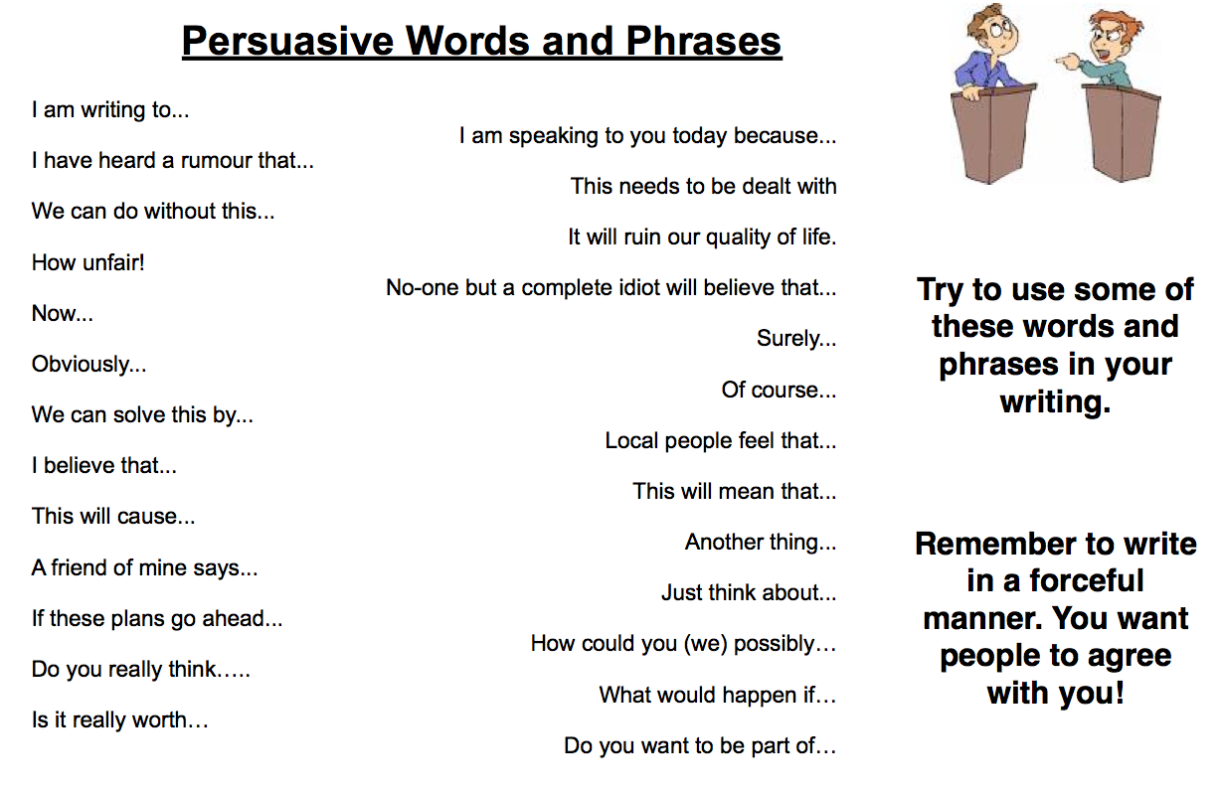
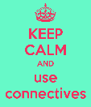
asier to read.
You will lose marks if your writing is not in paragraphs

- A paragraph is a group of sentences, which talk about the same thing and develop an idea.

- Use a new paragraph to introduce a new idea, topic, place or time.

- To indicate a new paragraph, start a new line and leave a space (indent) at the beginning of the line.

- The first sentence of a paragraph is often a topic sentence, which gives you the main idea of what the paragraph is going to be about.

- Develop your ideas in the paragraph with two or three more sentences.

Remember: Your paragraphs should always be longer than one sentence. Read through your work and check to make sure you have used punctuation to break up long sentences

Use the following three steps to write your paragraphs:

- Topic sentence (introduce main idea of your paragraph)

- Develop your points/idea using two or three sentences

- Use connectives to link paragraphs and progress your ideas

Connectives

Use connectives, or joining words, to link your sentences together and form your paragraphs.

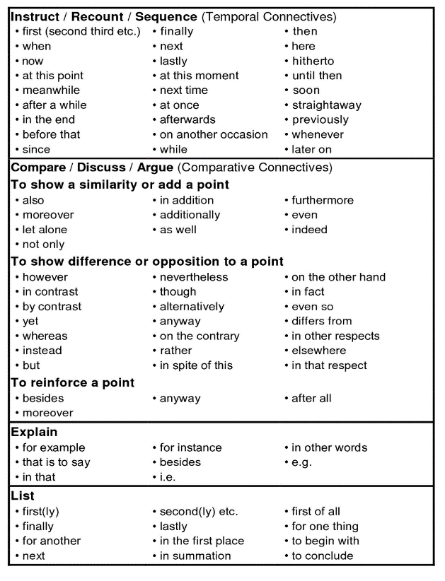

Using Joining Words to Link Ideas

Use ‘for example’ or ‘for instance’ to back up your point.

Example: Owning a pet can be expensive, for example costly vet’s bills.

Practice questions: choose ‘therefore’, ‘for example’ or ‘however’ to complete these sentences.

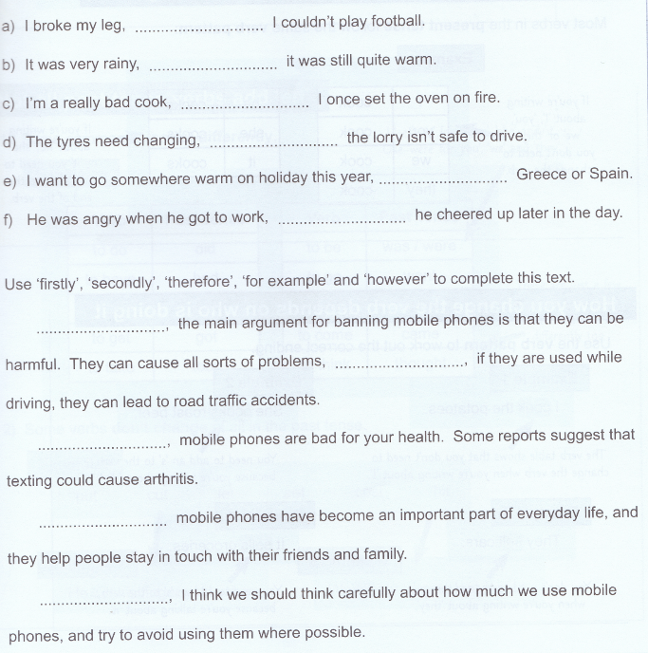

Common Grammatical Errors

Its or it’s?

Its – when it means `belonging to it’, it doesn’t have an apostrophe.

For example:
- The group made its decision.

- The bird ruffled its feathers.

The only time ‘its’ has an apostrophe is when it means `it is’ or `it has’.

It’s is a contraction, where the apostrophe takes the place of missing letters.

For example
- It’s going to rain.

- It’s been a lovely day.

Write the correct it’s/its in these sentences. Try saying the sentence out loud – if you can use `it is’ or `it has’ in the gap, use `it’s’.

- I don’t know if _____ a good idea.

- The cat ate all _____ dinner.

- _____ a good day to go for a walk.

- The book has lost ___cover.

- _____ not fair.

- Have you seen my coat? _____ gone missing.

- That shirt has one of ______ buttons missing.

- My dog has a black spot on _____ ear.

- Is it still snowing? No I think_____ stopped now.

10._____ almost the end of the lesson.

Don’t put an apostrophe in its unless you mean it is

Then versus Than
- ‘Then’ is used when talking about time. For example: I bought a Kindle, and then I downloaded my favourite novel.

- ‘Than’ is used for comparisons. For example: My Kindle is much lighter than my book.

Loose versus lose
- If something doesn’t fit properly, it is loose. For example: The key is loose in the lock.

Lose is used to refer to something that has been lost. For example: I always lose my keys.

There versus their versus they’re
- These three homonyms are always getting muddled up on websites and in emails. It is always worth extending the sentence in your head to find the right match.

  - ‘There’ is used to indicate a place. For example: Look over there!
  - ‘Their’ is the possessive case of they. For example: I think they’ve forgotten their books.
  - ‘They’re’ is a contraction of they are. For example: They’re looking forward to the Book Fair.

Articles or determiners in the wrong place, or missing altogether:
a) I bought new computer last weekend.
b) I had some interesting journey to work this morning.

Use articles correctly:
a) I bought a new computer last weekend.
b) I had an interesting journey to work this morning.

Using the Apostrophe

There are only two occasions when you need to use the apostrophe:

- Contraction – when letters are removed to shorten words or join them together. For example: do not becomes don’t, or they are becomes they’re.

Apostrophes show you that some letters have been taken out of a word to shorten it. For example: Do not becomes don’t. I will becomes I’ll. Could have becomes could’ve.
The apostrophe goes where the letters have been removed. Apostrophes are used this way in informal writing.
NOTE: sometimes words are shortened in an irregular way. The apostrophe, however, is still used to show where letters are missing. For example: Will not becomes won’t.
You should not shorten words, or use contractions when you are writing formal letters

2. Possession – to show ownership; for example the teacher’s pen.

Apostrophes show that something belongs to or is connected with something else.
To show belonging you add: ’s
The cat’s tail - says that the tail belongs to the cat. The newspaper’s readers - says that the readers are connected with the newspaper. Tony’s hair - says that the hair belongs to Tony.
NOTE: usually the apostrophe goes before the ‘s’. However, if the owner already ends in ‘s’ then the apostrophe goes after the ‘s’ that is already there. You just need to add an apostrophe.
For example: The dogs’ bowls - says that the bowls belong to some dogs. The boys’ coats - says that the coats belong to some boys. The cars’ wheels - says that the wheels belong to some cars.
Watch out for plurals that don’t end in ‘s’. Words like ‘men’ and ‘children’ don’t end in ‘s’, but they are talking about lots of people. These words use ’s to show possession. For example:
The men’s hats - says that the hats belong to the men. The women’s house - says that the house belongs to the women

Remember – You do NOT use the apostrophe to
indicate a plural

Writing a Formal Letter

- The success of a formal letter depends a great deal on correct layout and organisation.
- You need to know where to place your address and the address of the person you are writing to.
- You need the date and the correct from of greeting.
- You need to use the correct form of signing off.
- You must write in standard formal English.
- Avoid using contractions in formal writing
- Use persuasive techniques if you need to.

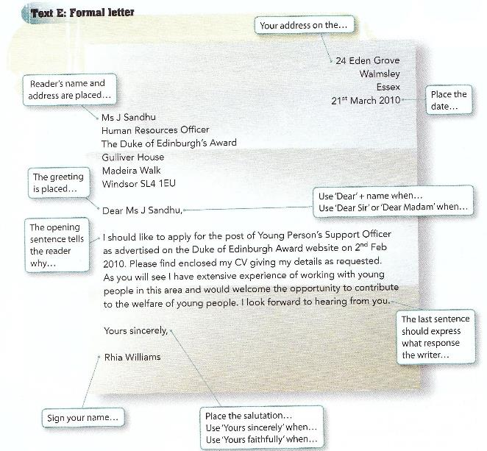

Signing off a letter

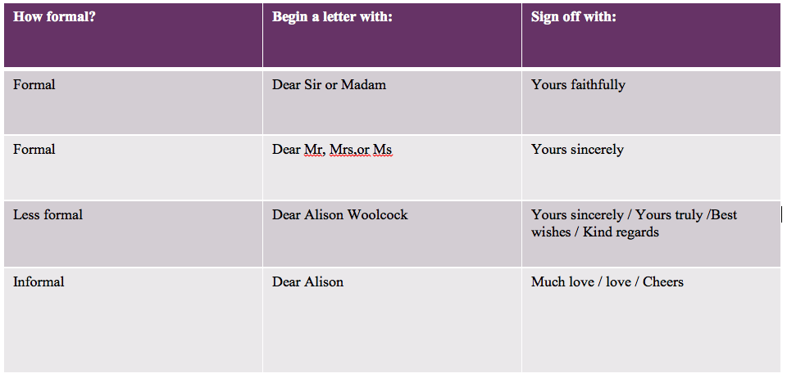

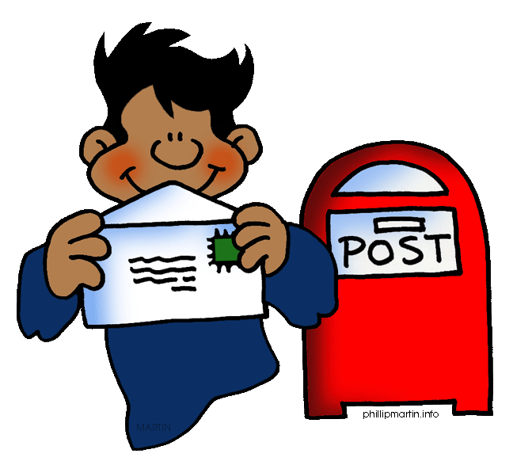

Writing an Article

- What is the purpose? Who are the audience?

- What are your opinions on the topic?

- Catchy headline to grab reader’s attention.

- Keep your reader interested with a strong opening paragraph, which creates an introduction to your subject, perhaps including some background or history.

- Organise your ideas using paragraphs.

- Provide evidence or reasons for every argument you make.

- Don’t forget to use subheadings.

- Include a counter argument or opinions if you are writing to persuade or creating an article – then argue your case.

- Include other viewpoints and comments, or facts and statistics.

- Include details of how to get further information.

- A clear, strong conclusion, which leaves the reader with a definite picture of your opinions.

Tone and Style
- You need to write for your audience.

- Although you need to use a formal style overall, the tone of your article can have a personal touch – if appropriate to your reader.

- Involve and convince your audience.

- Opening and closing statements should have impact and leave an impression.

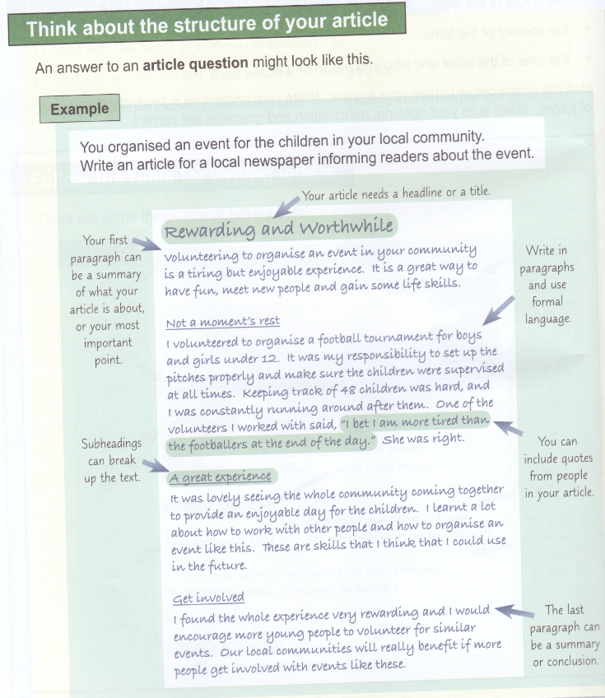

Writing a Leaflet

Leaflets can have different purposes

- A leaflet can provide information about something
- A leaflet can persuade a reader to do something

Know who your audience is

You need to make sure the language and style used in the leaflet suits the audience. You might use formal and serious language for a leaflet about fire hazards at home. You might use less formal language for a leaflet persuading people to come to an event you are organizing.

Information in a leaflet needs to be laid out clearly

Brief Example
Give your leaflet a title

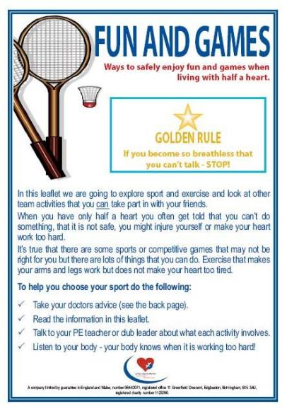

Use the first paragraph to give a summary of your leaflet
Provide as much important
information as possible

You can break up information into
Bullet points or numbered lists

You can use subheadings

Writing a Review

You may be asked to write a review about a place, event or even a facility. A review gives your opinion about something. Your task will be to inform the public of your experiences, positive or negative.
Here are some guidelines for writing a review. Introduce what you are going to be reviewing in your opening paragraph. Then, use a new paragraph for each new point or idea you make in your review. Give detailed reasons why you like or dislike something.
Be Opinionated: First and foremost, be bold and strong. Give your true opinion but do not say simply “I think that Estrick Shopping Centre is rubbish!” It is better to write, “Estrick Shopping Centre is a dreary, out-of-date mall with a monotonous range of shops”. Or, be very positive: “Estrick is a fantastic place for shopping, there are outlets to suit everyone’s taste and budget”.
Add Facts: Most reviews mix facts with the basic opinions. Information could include the running time of a movie, for example, or the opening times of a particular shopping outlet. Without some facts your review will be too short of substance and leave the reader without the opportunity to find out for themselves whether they agree with you.

Be Detailed: If you don't like something, explain why. Don't just say, "Estrick bowing alley is dull." Instead, describe why it is so boring. Is it out of date? Does it need some restaurants and bars to liven it up? Does it need updating? You want your audience to understand why you had the reaction you did.
Develop a Rating System of Your Own: One of the best parts of writing a review is giving a rating. Some people use stars, others use the "thumbs up/thumbs down" method.
Give Suggestions: It's appropriate to make some suggestions for improvements or change. For example: “although the transport system works adequately for most people in Estrick, it would be so much better if more buses ran at regular intervals during peak times to enable students to get to college on time”.

Finally: In the end, your audience is looking for you to give them some direction, so don't hold back. Be fair, be honest, and you'll wind up with a great review.

Writing a Report

When you write a report:
- Include a heading that makes the purpose of the report clear (e.g. ‘Report on …)
- Organise the information you want your reader to know so that it is easy to find.
- Use headings, bullet lists, numbered lists and different type styles such as bold or italics to help readers find the information they need.
- Tell readers why the report is being written in the introduction.
- Use the main part of the report to explain what evidence was gathered and what you think it means.
- Sum up your findings in a conclusion, and then make recommendations.
- Include facts and figures as evidence.
- Write in formal Standard English.

Suggestions for headings:
- Title of the report
- Purpose of your report (underneath this heading write an introductory sentence which tells the reader why the report is being written).
- Key factors to consider
- Recommendations
- Conclusion

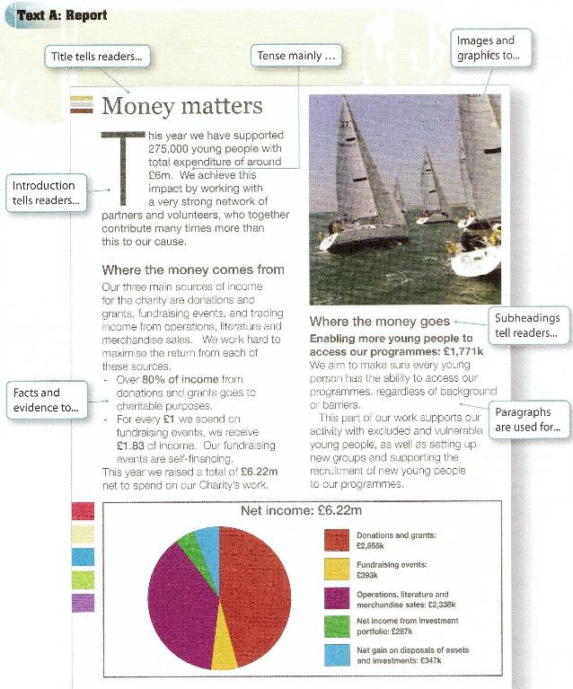

Writing a Message for an Internet Discussion

You may be asked to read two contributions to an Internet discussion and then write your own message in response to the views given.

You will need to say whether you agree or disagree with the views of the previous contributors and give your own views in detail.

In other words, you need to give your own opinion about something. Your opinion can’t be right or wrong, however you will have to back it up with evidence.
This is the writer’s opinion

For example:
Parents, not schools, should be responsible for teaching their children to read. Children learn more quickly when they are taught one-to-one.

This is the evidence to support the writer’s opinion

Your opinion will sound more convincing if it is supported by evidence
It is fine to have opinions for both sides of an argument...you may agree, or disagree with something said by the previous contributors to an internet discussion. You can quote what they say; for example:

‘Lucy, I agree with you when you say that: “teenagers spend too much time watching TV”.’

However, you need to include your opinion on this matter too – don’t just repeat what has already been said. If you disagree with a contributor then say so, but back this up with evidence. Always use language that is polite and respectful, write in Standard English – not slang.

Remember to structure your argument in paragraphs.

Finally, try to reach a conclusion – choose one opinion over the other.

Writing Emails

- It is really important that the style of your email is right for the audience.

- Make sure you read the question carefully so you are clear how formal your language should be.

- When you are emailing a company, someone in authority, or someone you do not know personally, then you should always use formal language.

- If you are asked to email a friend, then your language can be less formal. However, always remember you are being tested on your writing skills so this does not mean you should start using abbreviations, slang and jargon in your email. Always use Standard English.

- In the exam you will be given an email template to write your answer in and this will normally include an email address of the recipient.

- Important: Always open and close your email appropriately. You will not need to set out addresses, as you would if writing a letter, however you will need to start and close your message correctly.

- If you are writing a formal email do not write ‘Hi Christine’ or ‘Hi there’ – this is far too informal. You should always open as if you are writing a formal letter; for example:

- Dear Mr. Brown / Mrs. Brown / Miss Brown / Ms. Brown (if we do not know a woman’s marital status)

Sign off in the same way as a formal letter:

- Yours sincerely – if you know the name of the recipient
- Yours faithfully – if you are writing to an unnamed recipient

- If you are writing to a friend then your language can be friendlier with a less formal tone – sign off with ‘Best wishes' or ‘Best regards’.

- Remember to always write in paragraphs and use all the information in the question to structure your response.

Writing a Briefing Paper

Briefing papers are used to give information on particular subjects, and suggest possible courses of action. When writing a briefing paper remember:
  - You are writing for a particular audience. Ask yourself what they already understand and what they need to know.
  - State who the paper is for at the top left of your page
  - Give your paper a title that makes its purpose clear

Organise information under the following headings:
    - Issue – what it is about, why your audience should read it
    - Background – information, history and explanations
    - Considerations
      - Options – what could be done
      - Pros - advantages of the considerations
      - Cons - disadvantages of the considerations
      - Analysis – what you need to consider overall
    - Conclusion – what the current situation is and what should happen next

  - Use different ways of presenting information – bullet lists, numbered lists etc. –to help readers find the information they need.

  - Write in Standard English.

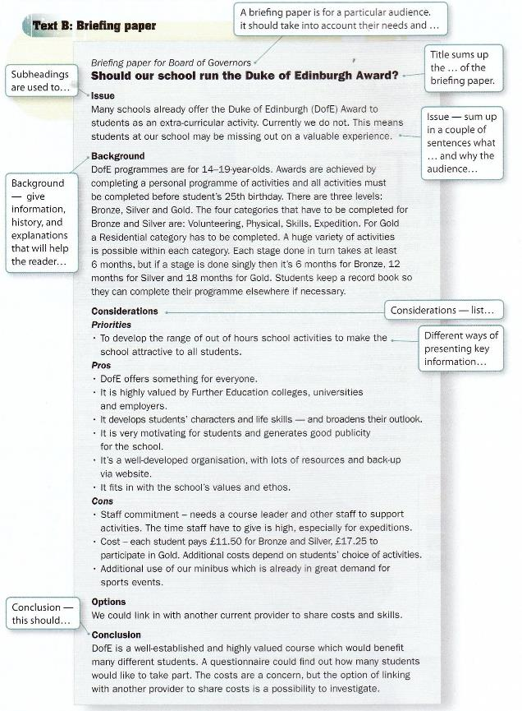

Example of a Briefing Paper Exam Question

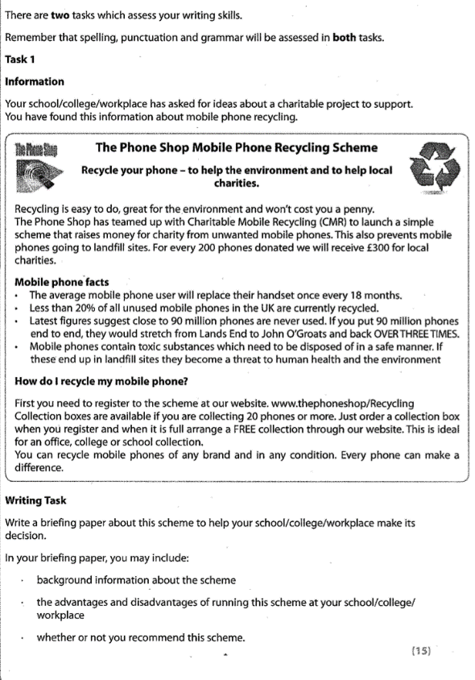
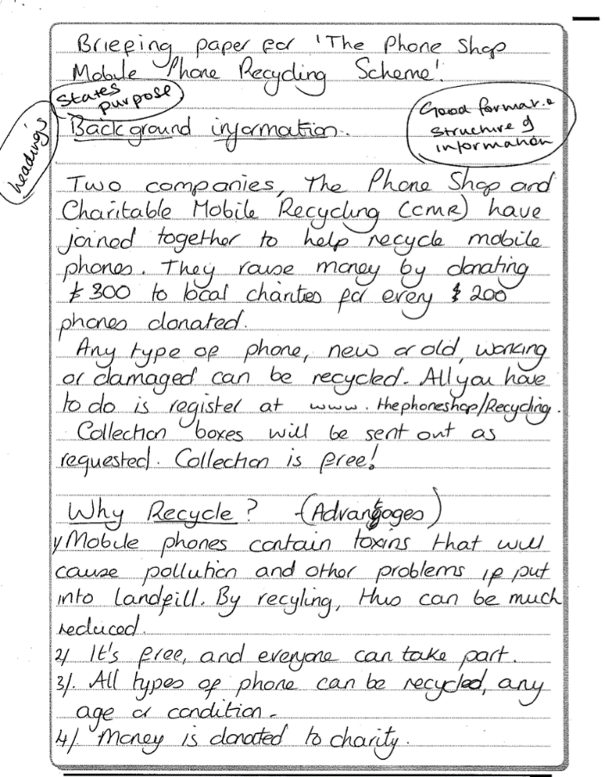

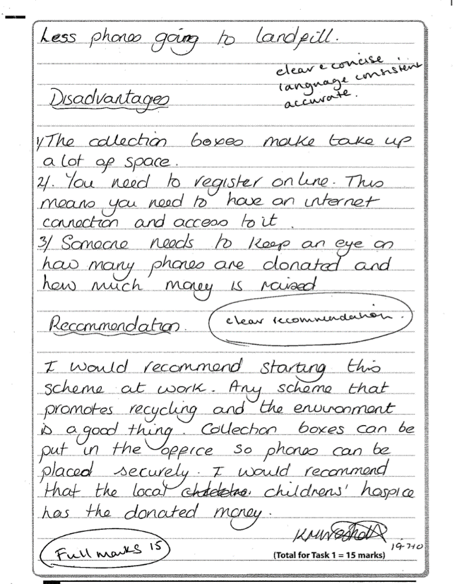

Check your Work

- After you have finished writing, always read your work through to check you have used spelling, punctuation and grammar correctly.

- Look out for any one-sentence paragraphs.

- Make sure you have used commas, full stops, apostrophes and question marks accurately.

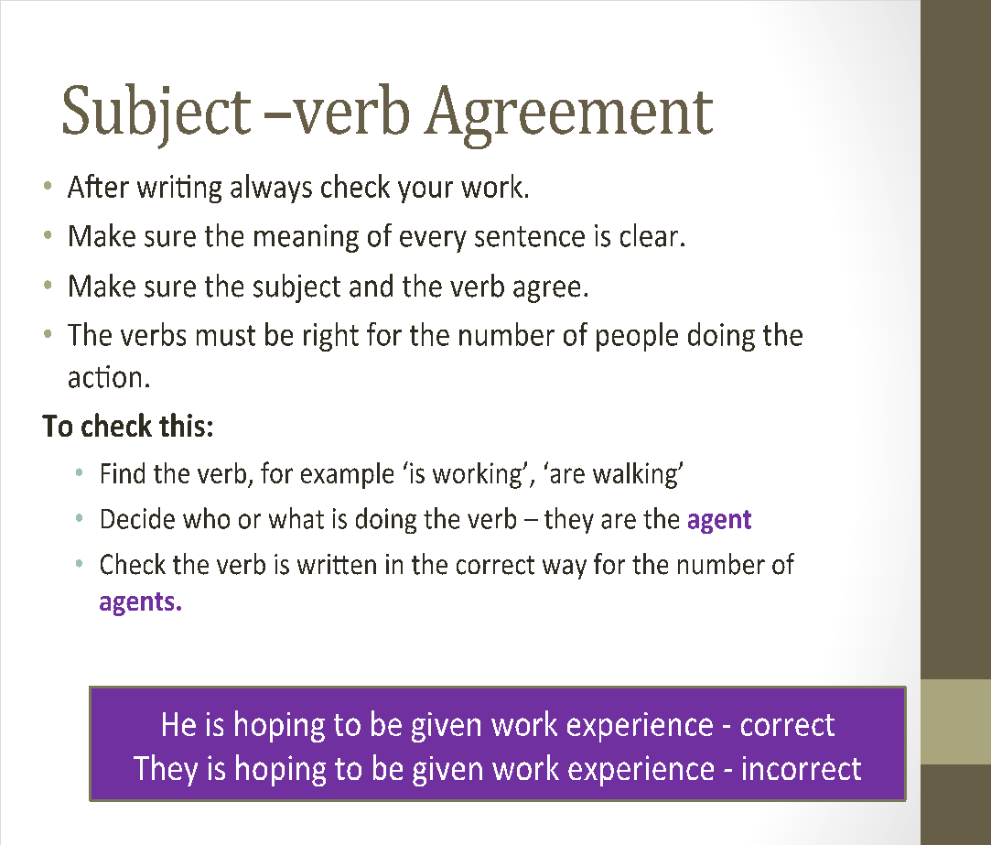

Writing practice questions – spend 45 minutes on each set of questions.

Set 1 Task 1
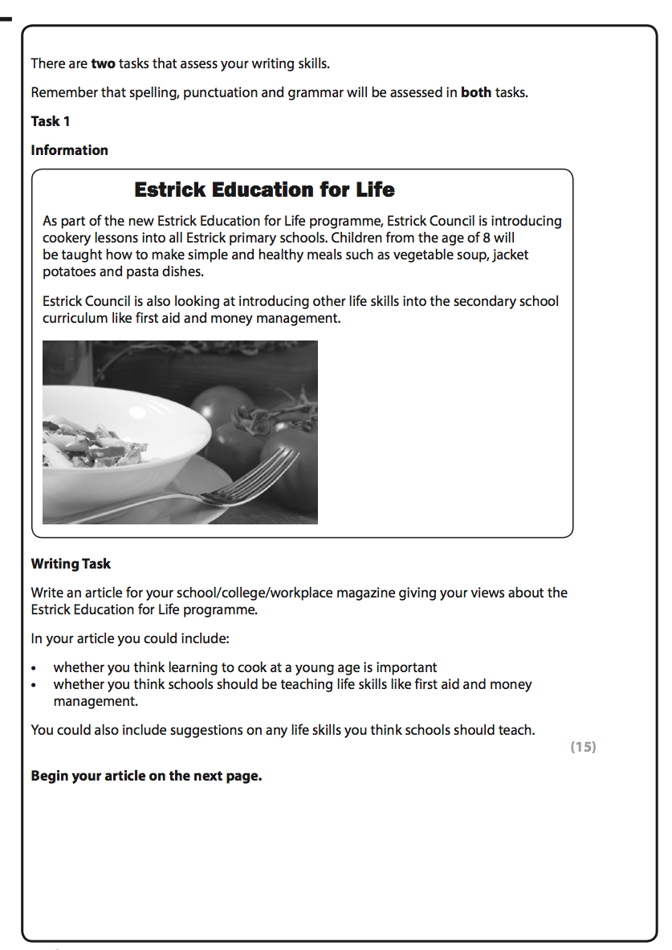
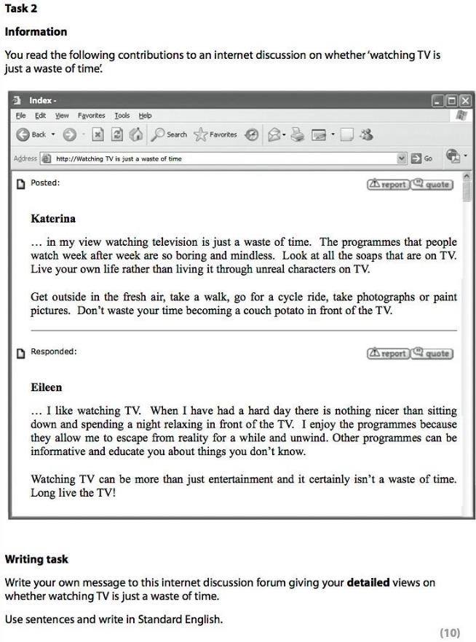

Writing practice questions – Set 2

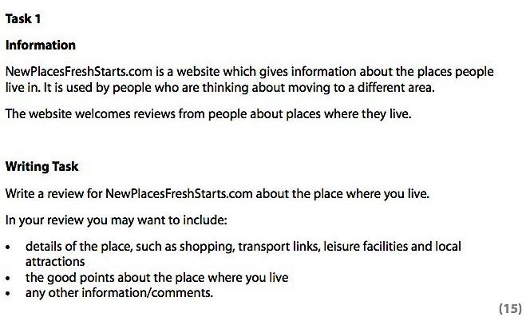

Set 2 - Task 2

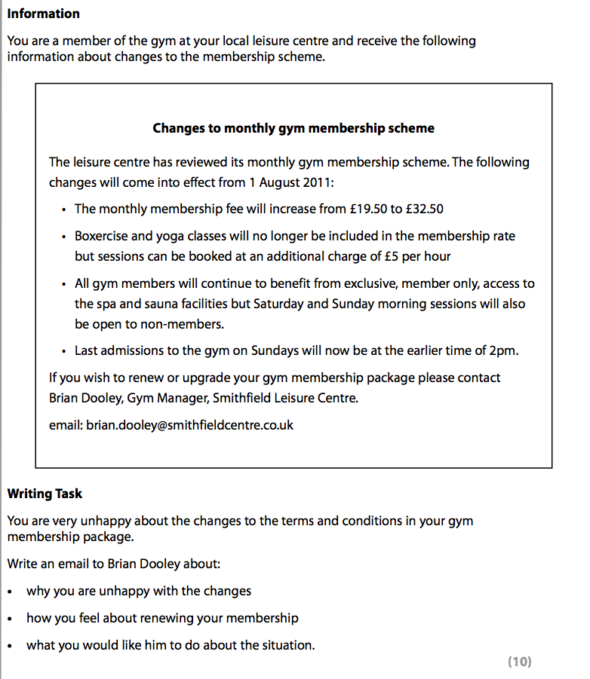

Set 3 - Task 1
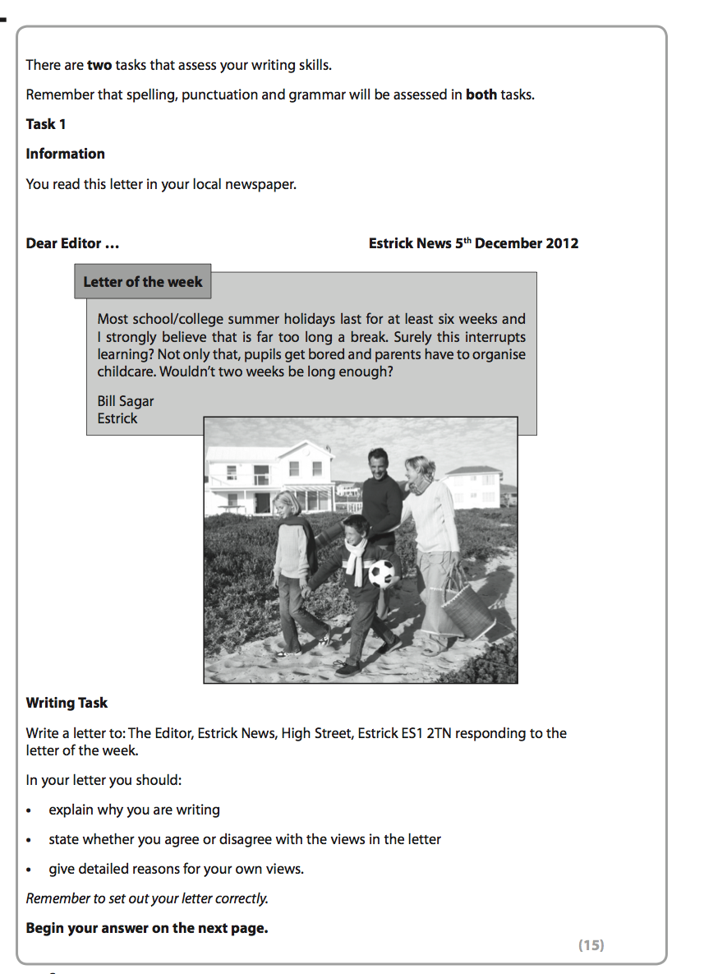

Set 3 – Task 3

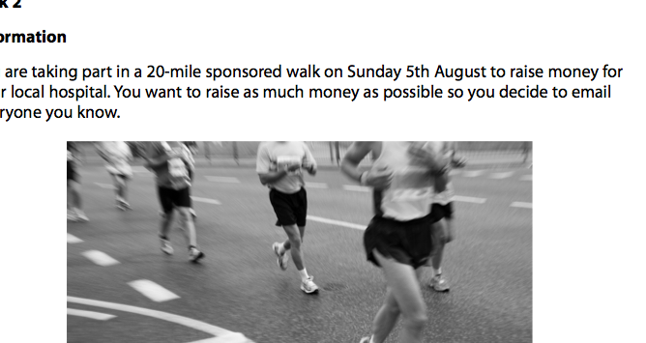

A Final Checklist

Check your work…Are you using… | Tick if you are confident
Correct format for each question type?
Varied punctuation?
A variety of sentence types?
Connectives?
Topic sentences?
Paragraphs with more than one sentence?
Links between paragraphs?
Commas to separate clauses?
Standard English?
Apostrophe correctly?
Subject-verb agreement?
Accurate spelling?
Contractions? Avoid these in formal writing.

Do you know how to… | Tick if you are confident
Set out a formal letter?
Open and close a formal letter appropriately?
Use the correct sign off in a formal letter?
Write an email to a friend?
Write a formal email?
Write an article?
Join an internet discussion?
Write a leaflet?
Write a review?
Write to persuade?
Write to advise or instruct?
Use descriptive language?

